

**JAPANESE COMMUNICATION AND CULTURE LEARNING PLATFORM**

**Software Design Specification**

– Danang, June 5 2025 –

**Record of changeS**

| **Date** | **A* M, D** | **In charge** | **Change Description** |
| --- | --- | --- | --- |
| 14/6/2025 | A | All | Initial |
| 28/6/2025 | M | Hoang | Change Database schema imported from Sql Server |
| 1/7/2025 | M | Hoang, Minh Khoi | Refactor some Class and Sequence diagrams |
| 3/7/2025 | M | Minh Phu | Update Class Diagram for “Register Account” (UC-01) |
| 4/7/2025 | M | Minh Khoi | Add placeholder Sequence Diagram for “Apply as Native Partner” (UC-02) |
| 4/7/2025 | A | Van Hoang | Add Database Queries for “Submit Verification Documents” (UC-03) |
| 4/7/2025 | M | All | Correct table descriptions under Database Design (Section II.2.b) |
| 5/7/2025 | A | Minh Phu | Introduce new package “BotIntegration” in Code Packages (Section I.1) |
| 5/7/2025 | M | Gia Khoi | Revise Class Specifications for “Login to the System” (UC-04) |
| 5/7/2025 | A | Minh Phu | Insert full Sequence Diagram for “Reset Password (Send OTP)” (UC-05) |
| 6/7/2025 | M | Minh Phu | Refine Class Diagram for “Logout System” (UC-06), align with SignInManager logic |
| 6/7/2025 | A | Minh Khoi | Standardize naming conventions across all Class Specifications subsections |
| 7/7/2025 | M | Gia Khoi | Add new Use Case “View Enrolled Learners” (UC-22) with Class & Sequence diagrams |
| 8/7/2025 | M | Van Hoang | Update Database Queries for “Buy Course” (UC-27) to include transaction rollback |
| 9/7/2025 | A | Minh Phu | Correct numbering in Table of Contents—ensure UC indices match actual page numbers |
| 10/7/2025 | M | Minh Khoi | Add Use Case “Rate Course” (UC-31) with full specifications and queries |
| 11/7/2025 | M | Gia Khoi | Refactor Sequence Diagram for “Create a Classroom” (UC-25a) to include validations |
| 12/7/2025 | A | Van Hoang | Update EF Migrations section: list latest Migration IDs and descriptions |
| 13/7/2025 | M | Gia Khoi | Add detailed specs for “View My Courses” (UC-29) including ViewModel definitions |
| 14/7/2025 | A | Minh Phu | Clarify difference between BotView and BotController in Code Packages section |

*A - Added M - Modified D - Deleted

**Table of Contents**

I. Overview 9

1. Code Packages 9

2. Database Design 11

a. Database Schema 11

b. Table Description 11

II. Code Designs 16

1. Register Account 16

a. Class Diagram 16

b. Class Specifications 16

c. Sequence Diagram 17

d. Database Queries 17

2. Apply as Native Partner 19

a. Class Diagram 19

b. Class Specifications 19

c. Sequence Diagram 20

d. Database Queries 20

3. Submit Verification Documents 22

a. Class Diagram 22

b. Class Specifications 22

c. Sequence Diagram 24

d. Database Queries 24

4. Login to the System 25

a. Class Diagram 25

b. Class Specifications 25

c. Sequence Diagram 26

d. Database Queries 26

5. Reset Password (Send OTP) 28

a. Class Diagram 28

b. Class Specifications 28

c. Sequence Diagram 29

d. Database Queries 30

6. Logout System 31

a. Class Diagram 31

b. Class Specifications 32

c. Sequence Diagram 32

d. Database Queries 33

7. View Profile Information 34

a. Class Diagram 34

b. Class Specifications 35

c. Sequence Diagram 36

d. Database Queries 36

8. Change Password 37

a. Class Diagram 37

b. Class Specifications 37

c. Sequence Diagram 39

d. Database Queries 39

9. Change Profile Information 40

a. Class Diagram 40

b. Class Specifications 41

c. Sequence Diagram 42

d. Database Queries 42

10. View User Accounts 43

a. Class Diagram 43

b. Class Specifications 43

c. Sequence Diagram 43

d. Database Queries 44

11. Create Account 45

a. Class Diagram 45

b. Class Specifications 45

c. Sequence Diagram 47

d. Database Queries 47

12. Edit Account 48

a. Class Diagram 48

b. Class Specifications 48

c. Sequence Diagram 49

d. Database Queries 50

13. Delete Account 51

a. Class Diagram 51

b. Class Specifications 51

c. Sequence Diagram 52

d. Database Queries 52

14. View Requested Partner List 53

a. Class Diagram 53

b. Class Specifications 53

c. Sequence Diagram 54

d. Database Queries 55

15. View Requested Partner’s Documents 56

a. Class Diagram 56

b. Class Specifications 56

c. Sequence Diagram 57

d. Database Queries 57

16. Approve Partner 58

a. Class Diagram 58

b. Class Specifications 58

c. Sequence Diagram 58

d. Database Queries 59

17. Reset User Password (Admin) 60

a. Class Diagram 60

b. Class Specifications 60

c. Sequence Diagram 62

d. Database Queries 62

18. View Classrooms List 64

a. Class Diagram 64

b. Class Specifications 65

c. Sequence Diagram 65

d. Database Queries 65

19. Search a Classroom 66

a. Class Diagram 66

b. Class Specifications 66

c. Sequence Diagram 67

d. Database Queries 68

20. View Classroom Details 69

a. Class Diagram 69

b. Class Specifications 69

c. Sequence Diagram 70

d. Database Queries 70

21. View Joined Classrooms 72

a. Class Diagram 72

b. Class Specifications 72

c. Sequence Diagram 73

d. Database Queries 74

22. View Classroom Dashboard 75

a. Class Diagram 75

b. Class Specifications 75

c. Sequence Diagram 76

d. Database Queries 76

23. Join Video Call 78

a. Class Diagram 78

b. Class Specifications 78

c. Sequence Diagram 79

d. Database Queries 79

24. View Managed Classrooms 81

a. Class Diagram 81

b. Class Specifications 81

c. Sequence Diagram 82

d. Database Queries 83

25. Create a Classroom 84

a. Class Diagram 84

b. Class Specifications 84

c. Sequence Diagram 85

d. Database Queries 86

26. Edit a Classroom 87

a. Class Diagram 87

b. Class Specifications 87

c. Sequence Diagram 88

d. Database Queries 89

27. Delete a Classroom 91

a. Class Diagram 91

b. Class Specifications 91

c. Sequence Diagram 92

d. Database Queries 92

28. View Enrolled Learners 94

a. Class Diagram 94

b. Class Specifications 94

c. Sequence Diagram 95

d. Database Queries 96

29. Host a Video Call 97

a. Class Diagram 97

b. Class Specifications 97

c. Sequence Diagram 98

d. Database Queries 99

30. View Course List 100

a. Class Diagram 100

b. Class Specifications 100

c. Sequence Diagram 102

d. Database Queries 102

31. Search a Course 105

a. Class Diagram 105

b. Class Specifications 105

c. Sequence Diagram 106

d. Database Queries 106

32. View Course Details 108

a. Class Diagram 108

b. Class Specifications 108

c. Sequence Diagram 109

d. Database Queries 109

33. Buy Course 112

a. Class Diagram 112

b. Class Specifications 112

c. Sequence Diagram 113

d. Database Queries 114

34. Confirm Course Payment 116

a. Class Diagram 116

b. Class Specifications 116

c. Sequence Diagram 118

d. Database Queries 118

35. View My Courses 120

a. Class Diagram 120

b. Class Specifications 120

c. Sequence Diagram 121

d. Database Queries 121

36. Watch Video Lessons 123

a. Class Diagram 123

b. Class Specifications 123

d. Database Queries 124

37. Rate Course 127

a. Class Diagram 127

b. Class Specifications 127

c. Sequence Diagram 127

d. Database Queries 128

38. View Courses (Admin) 129

a. Class Diagram 129

b. Class Specifications 129

c. Sequence Diagram 130

d. Database Queries 131

39. Create a Course 134

a. Class Diagram 134

b. Class Specifications 134

c. Sequence Diagram 135

d. Database Queries 136

40. Edit a Course 137

a. Class Diagram 137

b. Class Specifications 137

c. Sequence Diagram 138

d. Database Queries 139

41. Delete a Course 140

a. Class Diagram 140

b. Class Specifications 140

c. Sequence Diagram 141

d. Database Queries 142

# I. Overview

## 1. Code Packages

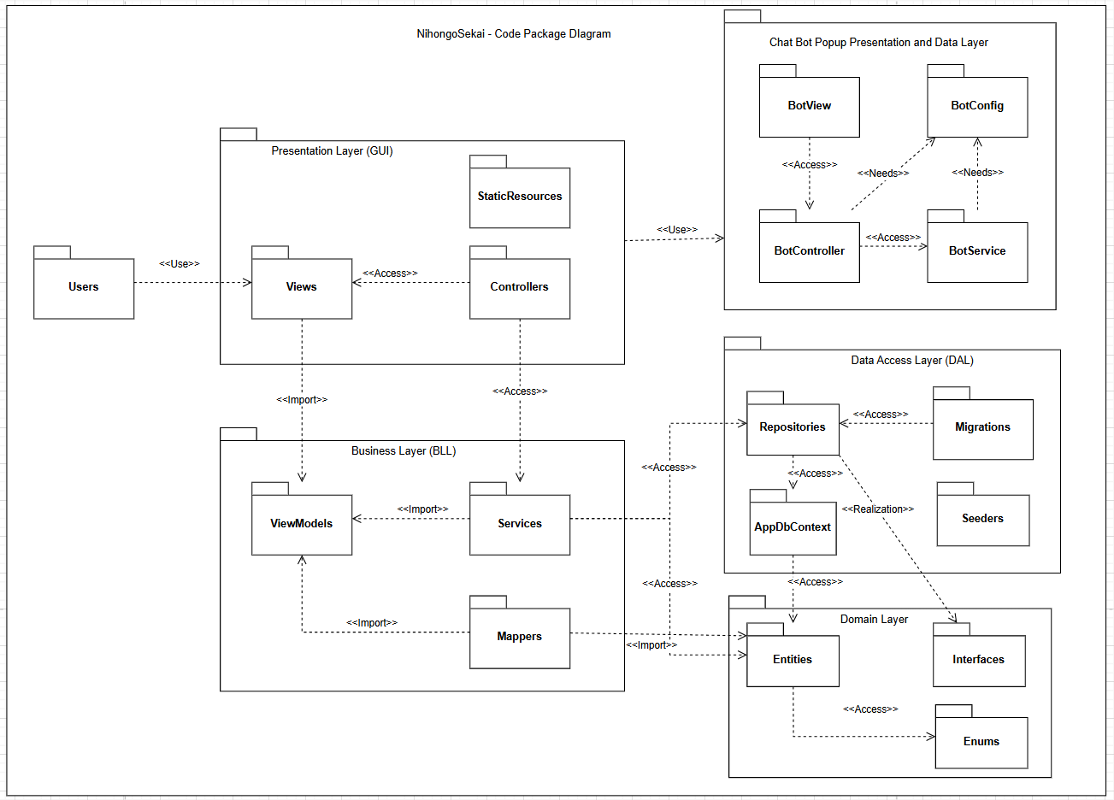

***Package descriptions***

| ***No.*** | ***Package*** | ***Description*** |
| --- | --- | --- |
| ***1*** | ***Users*** | *Represents external users interacting with the system (Learners, Admins, etc.).* |
| ***2*** | ***Views*** | *Front-end interface pages displayed to users, powered by data from ViewModels.* |
| ***3*** | ***Controllers*** | *Handle user requests, invoke services, and return appropriate views.* |
| ***4*** | ***StaticResources*** | *Includes static files such as CSS, JavaScript, images, and frontend assets.* |
| ***5*** | ***ViewModels*** | *Data transfer objects used between controllers and views; designed for display.* |
| ***6*** | ***Services*** | *Core business logic of the system, including orchestrating data from domain and DAL.* |
| ***7*** | ***Mappers*** | *Responsible for transforming data between Entities and ViewModels (e.g., DTO mapping).* |
| ***8*** | ***Entities*** | *Domain models representing core business concepts such as Course, Classroom, etc.* |
| ***9*** | ***Enums*** | *Enumerations used within entities to represent fixed value types (e.g., Status, Level).* |
| ***10*** | ***Interfaces*** | *Contract definitions for services and repositories, used for dependency injection and testing.* |
| ***11*** | ***Repositories*** | *Handle querying and persisting entities in the database using EF Core.* |
| ***12*** | ***AppDbContext*** | *Entity Framework Core database context; defines DB sets and relationships.* |
| ***13*** | ***Migrations*** | *Auto-generated classes to track and apply schema changes to the database.* |
| ***14*** | ***Seeders*** | *Populate the database with initial test/sample data during setup.* |
| ***15*** | ***BotView*** | *UI component of the chatbot popup, interacting with users within the app.* |
| ***16*** | ***BotController*** | *Controls logic for chatbot interactions, routing messages to appropriate services.* |
| ***17*** | ***BotService*** | *Handles chatbot backend processing, generating responses or triggers.* |
| ***18*** | ***BotConfig*** | *Stores configuration values for the chatbot like API keys or behavior rules.* |

## 

## 2. Database Design

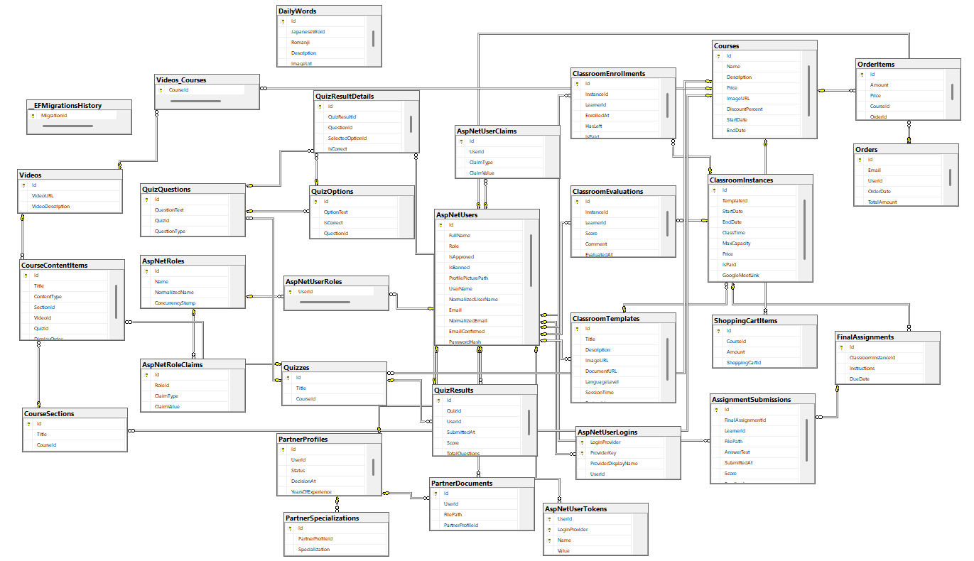

### 

### 

### b. Table Description

| No. | Table Name | Description |
| --- | --- | --- |
| 1 | AspNetUsers | Stores application users' information.  Primary key: Id  Foreign keys: -  Non-key fields: FullName, Role, IsApproved, PartnerDocumentPath, UserName, Email, PasswordHash, PhoneNumber, etc. |
| 2 | AspNetRoles | Stores role definitions for the identity system.  Primary key: Id  Foreign keys: -  Non-key fields: Name, NormalizedName |
| 3 | AspNetUserRoles | Associates users with roles (many-to-many).  Primary key: UserId + RoleId  Foreign keys: UserId → AspNetUsers, RoleId → AspNetRoles  Non-key fields: None |
| 4 | AspNetUserClaims | Stores claims associated with a user.  Primary key: Id  Foreign keys: UserId → AspNetUsers  Non-key fields: ClaimType |
| 5 | AspNetRoleClaims | Stores claims associated with a role.  Primary key: Id  Foreign keys: RoleId → AspNetRoles  Non-key fields: ClaimType |
| 6 | AspNetUserLogins | Stores external login information.  Primary key: LoginProvider + ProviderKey  Foreign keys: UserId → AspNetUsers  Non-key fields: ProviderDisplayName |
| 7 | AspNetUserTokens | Stores tokens for authentication purposes.  Primary key: UserId + LoginProvider + Name  Foreign keys: UserId → AspNetUsers  Non-key fields: Value |
| 8 | Courses | Stores course information.  Primary key: Id  Foreign keys: -  Non-key fields: Name, Description, Price, ImageURL, StartDate, EndDate, CourseCategory, DiscountPercent |
| 9 | Videos | Stores course video metadata.  Primary key: Id  Foreign keys: -  Non-key fields: VideoURL, VideoDescription |
| 10 | Videos_Courses | Join table for Courses and Videos.  Primary key: CourseId + VideoId  Foreign keys: CourseId → Courses, VideoId → Videos  Non-key fields: None |
| 11 | CourseSections | Stores sections under a course.  Primary key: Id  Foreign keys: CourseId → Courses  Non-key fields: Title |
| 12 | CourseContentItems | Stores individual content items in a course section.  Primary key: Id  Foreign keys: SectionId → CourseSections, VideoId → Videos, QuizId → Quizzes  Non-key fields: Title, ContentType, DisplayOrder |
| 13 | Quizzes | Stores quiz metadata.  Primary key: Id  Foreign keys: -  Non-key fields: Title |
| 14 | QuizQuestions | Stores questions in a quiz.  Primary key: Id  Foreign keys: QuizId → Quizzes  Non-key fields: QuestionText, QuestionType |
| 15 | QuizOptions | Stores answer options for quiz questions.  Primary key: Id  Foreign keys: QuestionId → QuizQuestions  Non-key fields: OptionText, IsCorrect |
| 16 | QuizResults | Stores quiz submission results by users.  Primary key: Id  Foreign keys: UserId → AspNetUsers, QuizId → Quizzes  Non-key fields: SubmittedAt, Score, TotalQuestions |
| 17 | QuizResultDetails | Stores details of quiz results for each question.  Primary key: Id  Foreign keys: QuizResultId → QuizResults, QuestionId → QuizQuestions, SelectedOptionId → QuizOptions  Non-key fields: IsCorrect |
| 18 | Orders | Stores orders made by users.  Primary key: Id  Foreign keys: UserId → AspNetUsers  Non-key fields: Email, OrderDate, TotalAmount |
| 19 | OrderItems | Stores course items under an order.  Primary key: Id  Foreign keys: OrderId → Orders, CourseId → Courses  Non-key fields: Amount, Price |
| 20 | ShoppingCartItems | Stores temporary course items in user's cart.  Primary key: Id  Foreign keys: CourseId → Courses  Non-key fields: Amount, ShoppingCartId |
| 21 | ClassroomTemplates | Stores templates for class creation.  Primary key: Id  Foreign keys: PartnerId → AspNetUsers  Non-key fields: Title, Description, ImageURL, LanguageLevel |
| 22 | ClassroomInstances | Stores actual class session info.  Primary key: Id  Foreign keys: TemplateId → ClassroomTemplates  Non-key fields: StartDate, EndDate, ClassTime, Price, GoogleMeetLink, MaxCapacity, Status |
| 23 | ClassroomEnrollments | Tracks learner enrollment in class sessions.  Primary key: Id  Foreign keys: InstanceId → ClassroomInstances, LearnerId → AspNetUsers  Non-key fields: EnrolledAt, HasLeft, IsPaid |
| 24 | ClassroomEvaluations | Learner feedback and score on a class.  Primary key: Id  Foreign keys: InstanceId → ClassroomInstances, LearnerId → AspNetUsers  Non-key fields: Score, Comment, EvaluatedAt |
| 25 | FinalAssessments | Stores final assessment info for a class instance.  Primary key: Id  Foreign keys: ClassroomInstanceId → ClassroomInstances  Non-key fields: Instructions, DueDate |
| 26 | AssessmentSubmissions | Stores learner submissions for assessments.  Primary key: Id  Foreign keys: FinalAssessmentId → FinalAssessments, LearnerId → AspNetUsers  Non-key fields: FilePath, AnswerText, SubmittedAt, Score, Feedback |
| 27 | EFMigrationsHistory | Tracks EF Core database migrations.  Primary key: MigrationId  Foreign keys: -  Non-key fields: ProductVersion |

# 

# II. Code Designs

## 1. Register Account

**Use Case:** UC-01: Register an Account

### a. Class Diagram

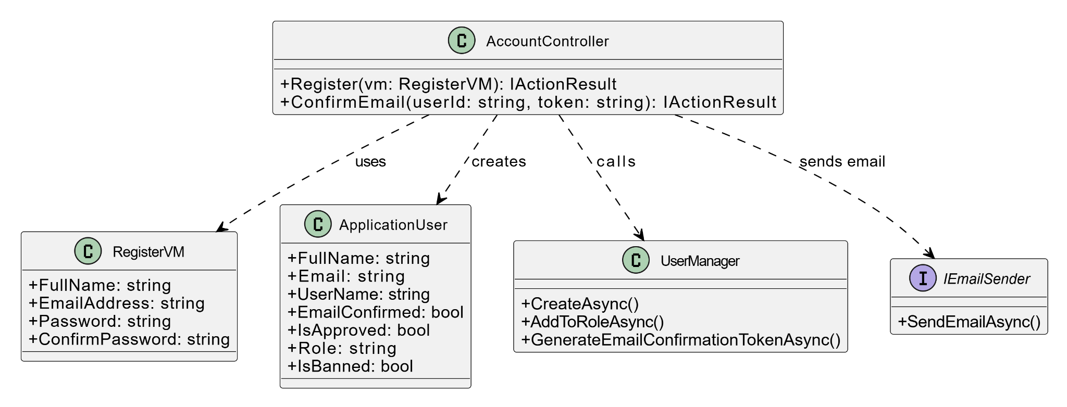

### b. Class Specifications

**AccountController**

| **No** | **Method** | **Description** |
| --- | --- | --- |
| 1 | Register(vm: RegisterVM) | Accepts registration form data, validates it, creates a new user, and sends a confirmation email. |
| 2 | ConfirmEmail(userId: string, token: string) | Confirms the email of a newly registered user by validating the token sent via email. |

**UserManager**

| **No** | **Method** | **Description** |
| --- | --- | --- |
| 1 | CreateAsync() | Creates a new user in the system with the provided credentials and data. |
| 2 | AddToRoleAsync() | Assigns a specific role (e.g., Learner, Partner) to the user. |
| 3 | GenerateEmailConfirmationTokenAsync() | Generates a secure token used to confirm the user's email address. |

**IEmailSender**

| **No** | **Method** | **Description** |
| --- | --- | --- |
| 1 | SendEmailAsync() | Sends a confirmation email to the user with a tokenized link to verify the account. |

### c. Sequence Diagram

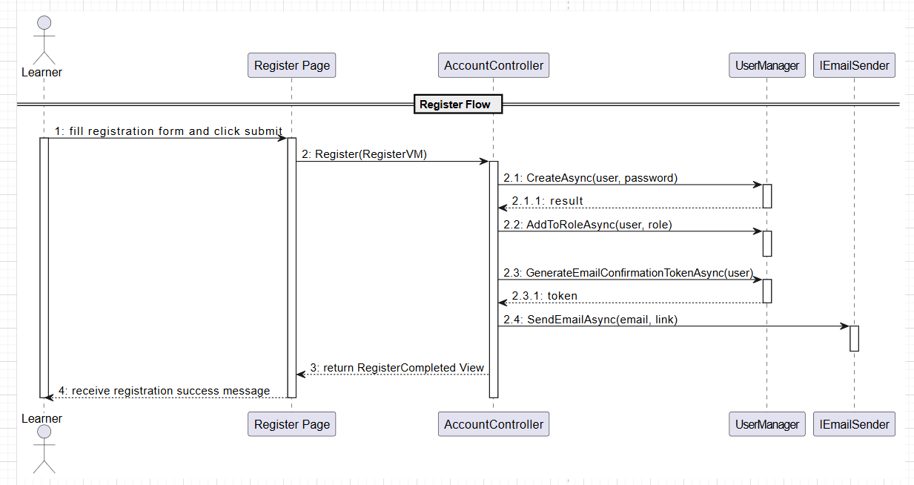

### d. Database Queries

INSERT INTO Accounts (name, email, password, role, status, createdAt)  
 VALUES (?, ?, ?, ?, 'PENDING_EMAIL', NOW()) RETURNING accountID  
 INSERT INTO Learners (learnerID, level, interest)  
 VALUES (?, 'BEGINNER', NULL)

## 

## 

## 

## 

## 

## 2. Apply as Native Partner

**Use Case:** UC-02: Apply as Native Partner

### a. Class Diagram

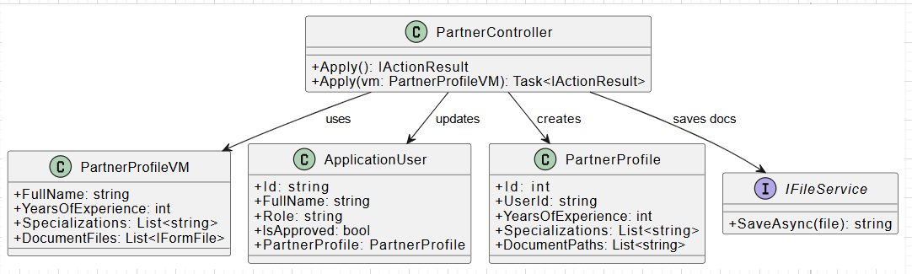

### b. Class Specifications

PartnerController

| No | Method | Description |
| --- | --- | --- |
| 1 | Apply() | Displays the partner application form. |
| 2 | Apply(PartnerProfileVM) | Validates and saves partner info and uploaded documents. Marks user as pending approval. |

PartnerProfileVM

| Property | Description |
| --- | --- |
| FullName | Full name of the partner |
| YearsOfExperience | Integer value indicating experience in teaching |
| Specializations | Selected teaching areas (e.g. JLPT, Business Japanese) |
| DocumentFiles | Uploaded verification documents |

IFileService

| No | Method | Description |
| --- | --- | --- |
| 1 | SaveAsync(file) | Saves file to the server and returns the storage path |

### c. Sequence Diagram

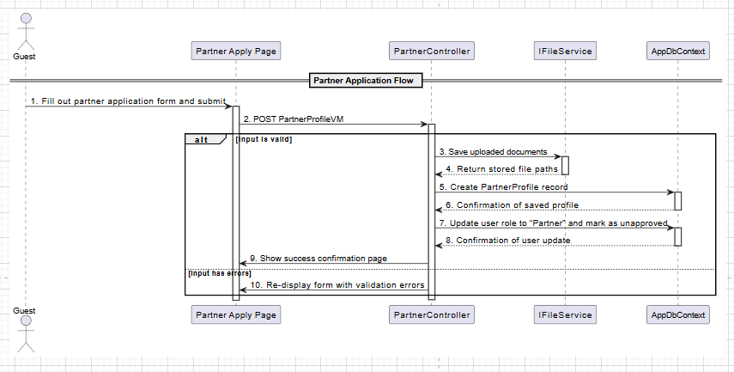

### d. Database Queries

-- Insert into PartnerProfiles

INSERT INTO PartnerProfiles (UserId, YearsOfExperience, Specializations, DocumentPaths)

VALUES (?, ?, ?, ?) RETURNING Id;

-- Update user role and approval status

UPDATE AspNetUsers

SET Role = 'Partner', IsApproved = FALSE

WHERE Id = ?

## 

## 

## 3. Submit Verification Documents

**Use Case:** UC-03: Submit Verification Documents

### a. Class Diagram

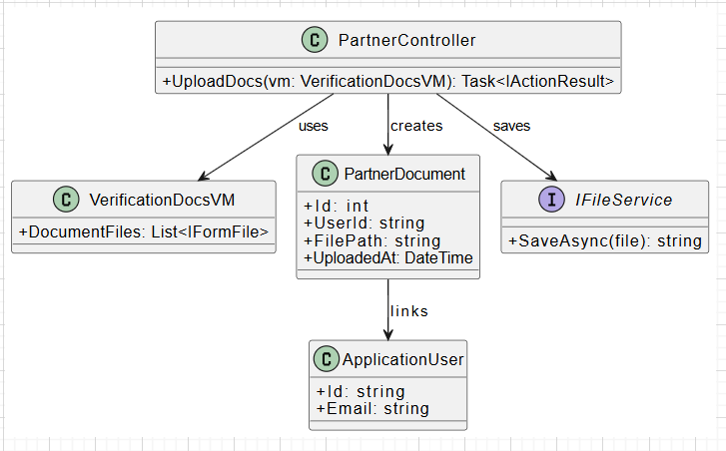

### b. Class Specifications

**PartnerController**

| **No** | **Method** | **Description** |
| --- | --- | --- |
| 1 | UploadDocs(VerificationDocsVM) | Accepts and stores verification documents for a partner. |

**VerificationDocsVM**

| **Property** | **Description** |
| --- | --- |
| DocumentFiles | List of uploaded files for partner verification |

**PartnerDocument**

| **Field** | **Description** |
| --- | --- |
| Id | Primary key |
| UserId | Foreign key linking to ApplicationUser |
| FilePath | Path to saved file |
| UploadedAt | Timestamp of upload |

**IFileService**

| **No** | **Method** | **Description** |
| --- | --- | --- |
| 1 | SaveAsync() | Saves uploaded file and returns the storage path |

### 

### 

### 

### c. Sequence Diagram

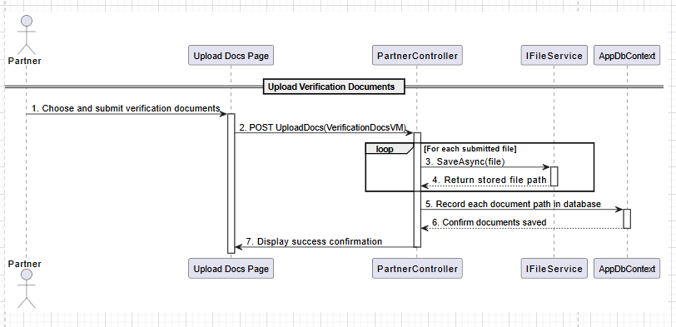

### d. Database Queries

-- Insert documents linked to partner user

INSERT INTO PartnerDocuments (UserId, FilePath, UploadedAt)

VALUES (?, ?, NOW());

## 4. Login to the System

**Use Case:** UC-04: Login to the system.

### a. Class Diagram

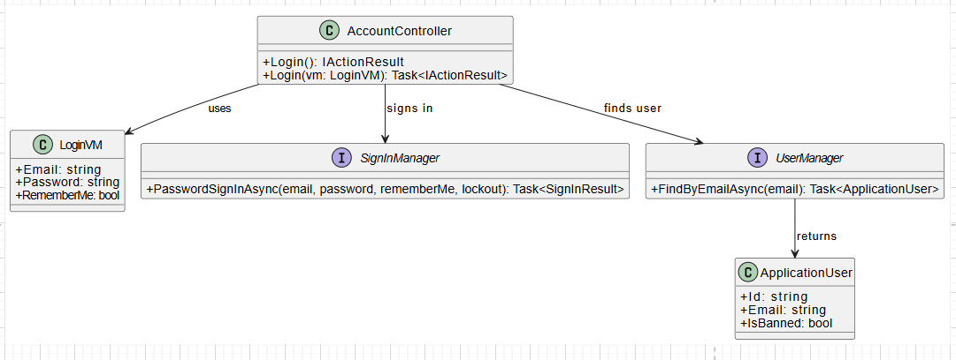

### b. Class Specifications

#### AccountController

| **No** | **Method** | **Description** |
| --- | --- | --- |
| 1 | Login() | Displays the login page. |
| 2 | Login(LoginVM) | Authenticates user using email and password. Redirects to home or returns error. |

#### LoginVM

| Property | Description |
| --- | --- |
| Email | Email address used to log in |
| Password | User's password |
| RememberMe | Whether to persist the session |

#### SignInManager

| **No** | **Method** | **Description** |
| --- | --- | --- |
| 1 | PasswordSignInAsync() | Authenticates user with password and manages login session. |

#### UserManager

| **No** | **Method** | **Description** |
| --- | --- | --- |
| 1 | FindByEmailAsync() | Finds user account object using email address. |

### c. Sequence Diagram

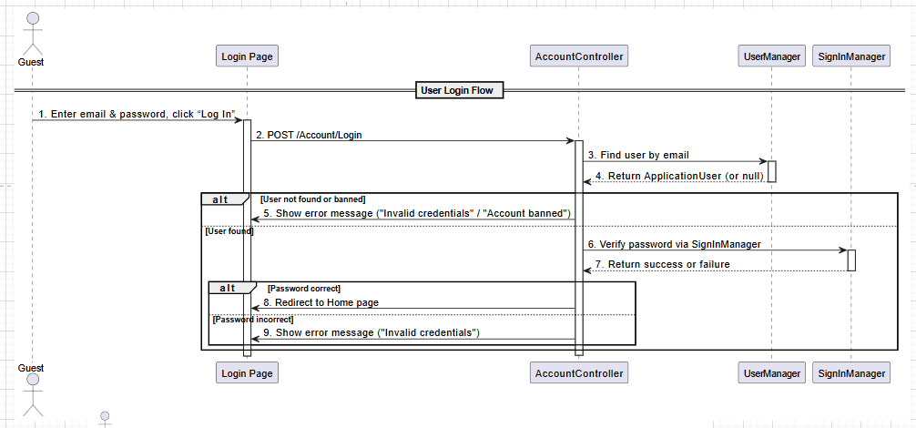

### d. Database Queries

-- Check if user exists and is not banned

SELECT * FROM AspNetUsers

WHERE Email = ? AND IsBanned = FALSE;

-- If valid, SignInManager handles session setup (internal logic)

## 

## 5. Reset Password (Send OTP)

**Use Case:** UC-05: Reset Password.

### a. Class Diagram

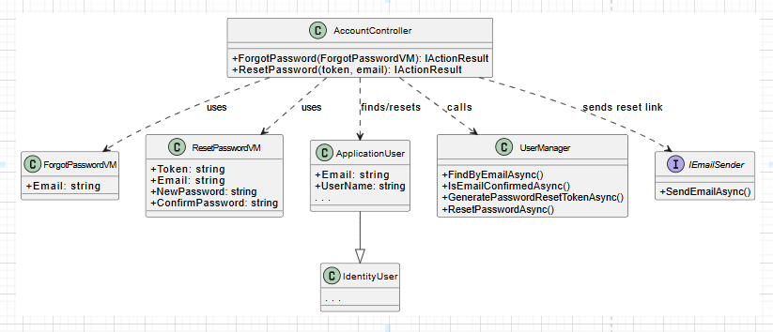

### b. Class Specifications

**AccountController**

| **No** | **Method** | **Description** |
| --- | --- | --- |
| 1 | ForgotPassword(ForgotPasswordVM) | Handles the user request to reset their password by verifying email and sending a reset link. |
| 2 | ResetPassword(token, email) | Displays the reset password form with the token and email passed from the email link. |
| 3 | ResetPassword(ResetPasswordVM) | Validates the token and email, and updates the password in the system. |

**UserManager**

| **No** | **Method** | **Description** |
| --- | --- | --- |
| 1 | FindByEmailAsync(email) | Finds a user based on their email address. |
| 2 | IsEmailConfirmedAsync(user) | Checks whether the user's email has been confirmed. |
| 3 | GeneratePasswordResetTokenAsync(user) | Generates a secure token for resetting the user's password. |
| 4 | ResetPasswordAsync(user, token, newPassword) | Resets the password using the provided token and new password. |

**IEmailSender**

| **No** | **Method** | **Description** |
| --- | --- | --- |
| 1 | SendEmailAsync(email, content) | Sends an email with the password reset link to the specified address. |

### 

### c. Sequence Diagram

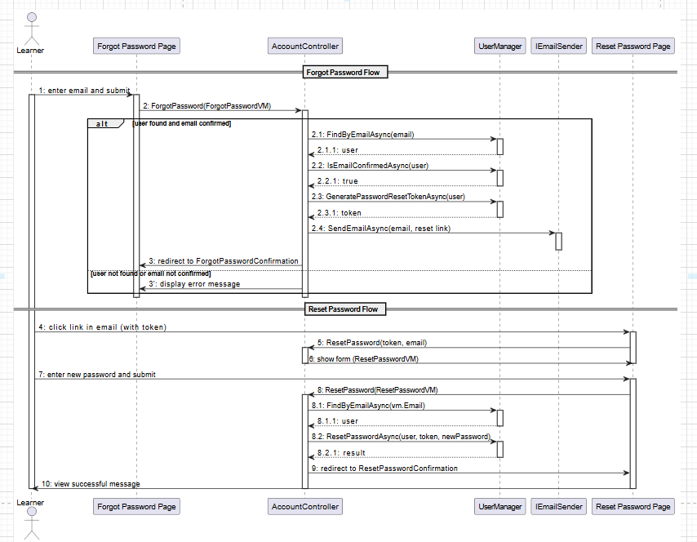

### d. Database Queries

SELECT *

FROM AspNetUsers

WHERE NormalizedEmail = UPPER(@Email);

INSERT INTO EmailLogs (UserId, Email, Subject, SentAt)

VALUES (@UserId, @Email, 'Reset Password Request', GETUTCDATE());

## 

## 6. Logout System

**Use Case:** UC-06: Logout System

### a. Class Diagram

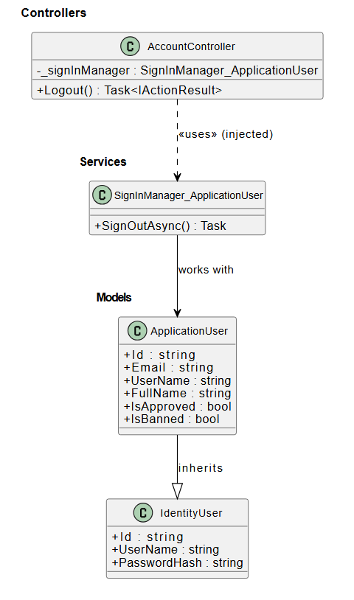

### b. Class Specifications

AccountController

| **No** | **Method** | **Description** |
| --- | --- | --- |
| 01 | Logout() | Handles the logout request from the user. Calls SignOutAsync() to terminate the authentication session and redirects to the homepage or login screen. Returns Task<IActionResult>. |

SignInManager<ApplicationUser>

| **No** | **Method** | **Description** |
| --- | --- | --- |
| 01 | SignOutAsync() | Asynchronously signs out the current user by clearing authentication cookies and session tokens. Called from the controller. Returns Task. |

### c. Sequence Diagram

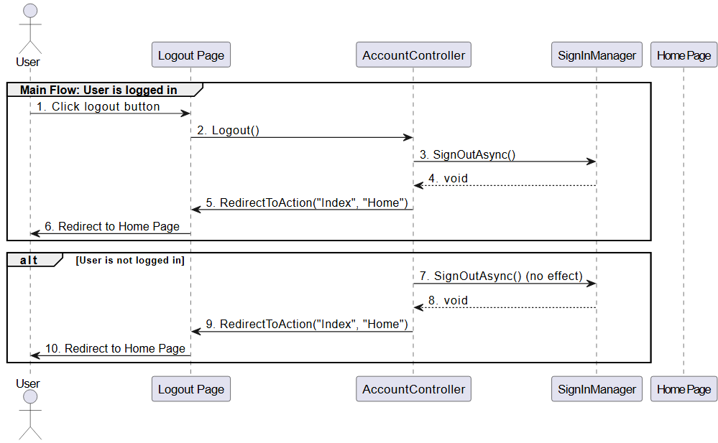

### d. Database Queries

INSERT INTO AuditLogs (UserId, Action, Timestamp)

VALUES (@UserId, 'Logout', GETUTCDATE());

## 

## 7. View Profile Information

**Use Case:** UC-07: View profile Information.

### a. Class Diagram

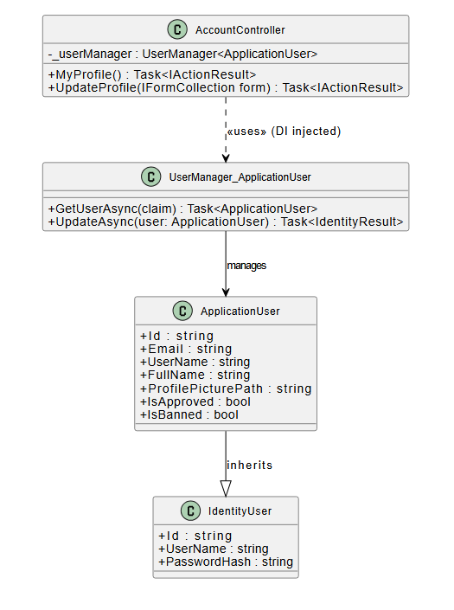

### b. Class Specifications

AccountController

| **No** | **Method** | **Description** |
| --- | --- | --- |
| 01 | MyProfile() | Returns the user's profile page. Retrieves the current user's information using UserManager.GetUserAsync(User) and displays it on the view. |
| 02 | UpdateProfile(IFormCollection form) | Handles the form submission when the user updates their profile. Extracts fields like FullName, Email, or ProfilePicturePath, and calls UserManager.UpdateAsync() to save changes to the database. |

UserManager<ApplicationUser>

| **No** | **Method** | **Description** |
| --- | --- | --- |
| 01 | GetUserAsync(ClaimsPrincipal) | Retrieves the ApplicationUser associated with the current session's claims. Used to fetch user details for display or update. |
| 02 | UpdateAsync(ApplicationUser) | Persists updated user information (e.g. name, email, avatar path) to the database. Returns an IdentityResult indicating success or failure. |

### 

### 

### 

### 

### 

### 

### 

### c. Sequence Diagram

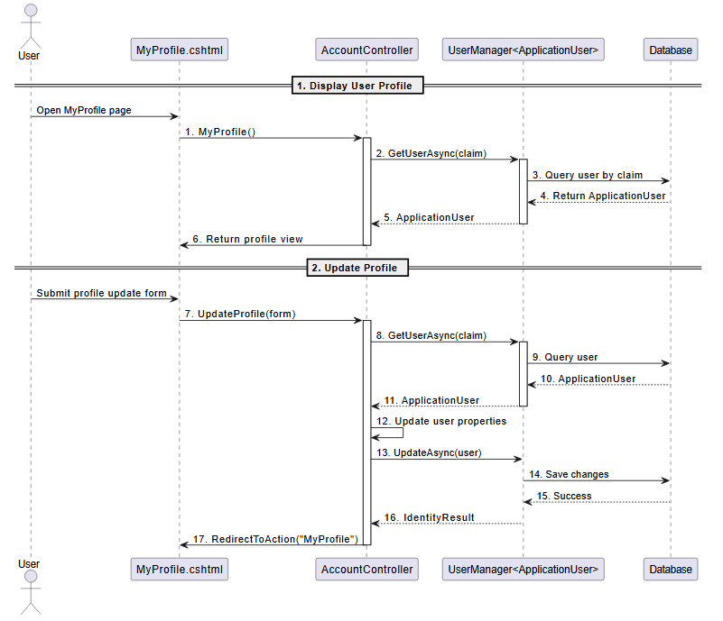

### d. Database Queries

SELECT Id, FullName, Email, Role, IsApproved, ProfilePicturePath

FROM AspNetUsers

WHERE Id = @UserId;

## 

## 8. Change Password

**Use Case:** UC-08: Change Password.

### a. Class Diagram

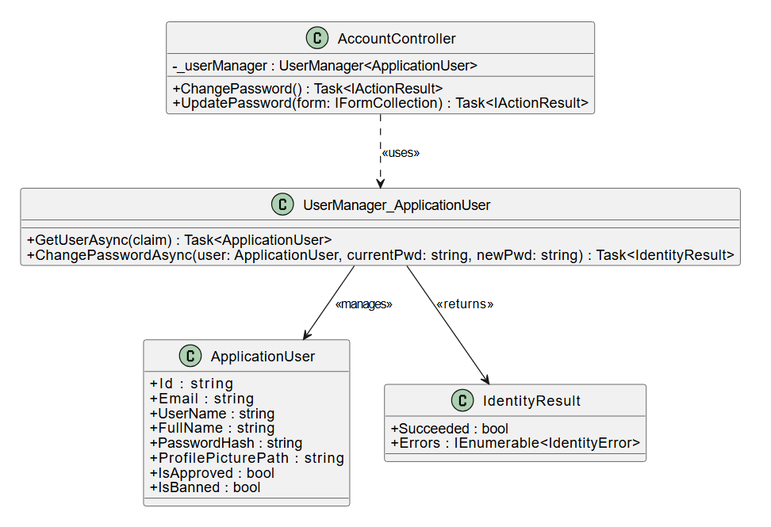

### b. Class Specifications

AccountController

| **No** | **Method** | **Description** |
| --- | --- | --- |
| 01 | ChangePassword() | Forwards to change-password.jsp to display the form. |
| 02 | UpdatePassword(IFormCollection form) | Handles the submitted password change form. Extracts current and new password fields, then calls UserManager.ChangePasswordAsync() to attempt updating the password. Returns appropriate success or error view. |

UserManager<ApplicationUser>

| **No** | **Method** | **Description** |
| --- | --- | --- |
| 01 | GetUserAsync(ClaimsPrincipal) | Retrieves the currently signed-in user based on claims identity. Used before password update to confirm user context. |
| 02 | ChangePasswordAsync(ApplicationUser user, string currentPassword, string newPassword) | Validates the current password, and if correct, updates the user’s password hash to the new password. Returns IdentityResult indicating success or listing validation errors. |

IdentityResult

| **No** | **Property** | **Description** |
| --- | --- | --- |
| 01 | Succeeded | A boolean indicating whether the password change was successful. |
| 02 | Errors | A collection of IdentityError objects describing why the operation failed (e.g., invalid password format, wrong current password). |

### 

### 

### 

### 

### 

### 

### 

### 

### 

### c. Sequence Diagram

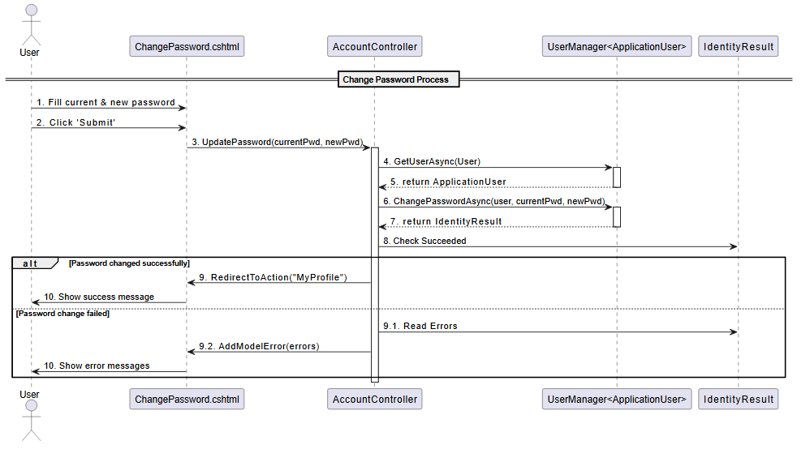

### d. Database Queries

SELECT *

FROM AspNetUsers

WHERE Id = @UserId;

UPDATE AspNetUsers

SET PasswordHash = @NewPasswordHash

WHERE Id = @UserId;

INSERT INTO AuditLogs (UserId, Action, Timestamp)

VALUES (@UserId, 'Change Password', GETUTCDATE());

## 

## 9. Change Profile Information

**Use Case:** UC-09: Change profile Information.

### a. Class Diagram

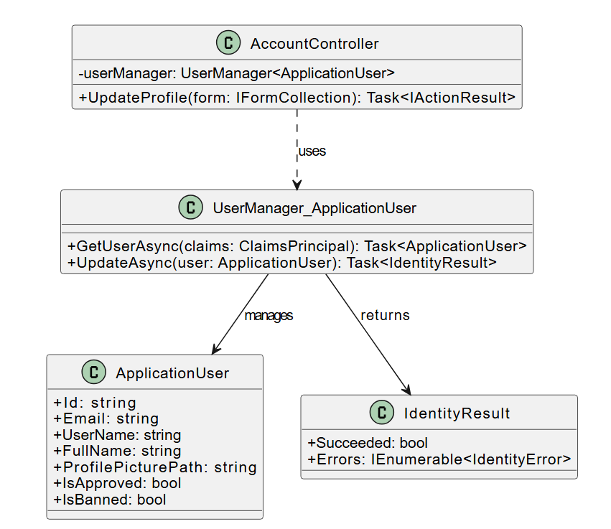

### b. Class Specifications

AccountController

| **No** | **Method** | **Description** |
| --- | --- | --- |
| 01 | UpdateProfile(IFormCollection form) | Handles form submission for profile updates. Extracts fields such as FullName, Email, or ProfilePicturePath from the request, updates the current ApplicationUser, and calls UserManager.UpdateAsync() to persist changes. |

UserManager<ApplicationUser>

| **No** | **Method** | **Description** |
| --- | --- | --- |
| 01 | GetUserAsync(ClaimsPrincipal) | Fetches the currently authenticated user based on claims in the request context. Returns an ApplicationUser object representing the current user. |
| 02 | UpdateAsync(ApplicationUser) | Updates user profile data in the database. Returns an IdentityResult that indicates whether the update was successful or includes validation errors. |

IdentityResult

| **No** | **Method** | **Description** |
| --- | --- | --- |
| 01 | Succeeded | Boolean value indicating whether the profile update was successfully committed to the database. |
| 02 | Errors | A list of IdentityError entries that describe why the update failed, if applicable. |

### 

### 

### 

### c. Sequence Diagram

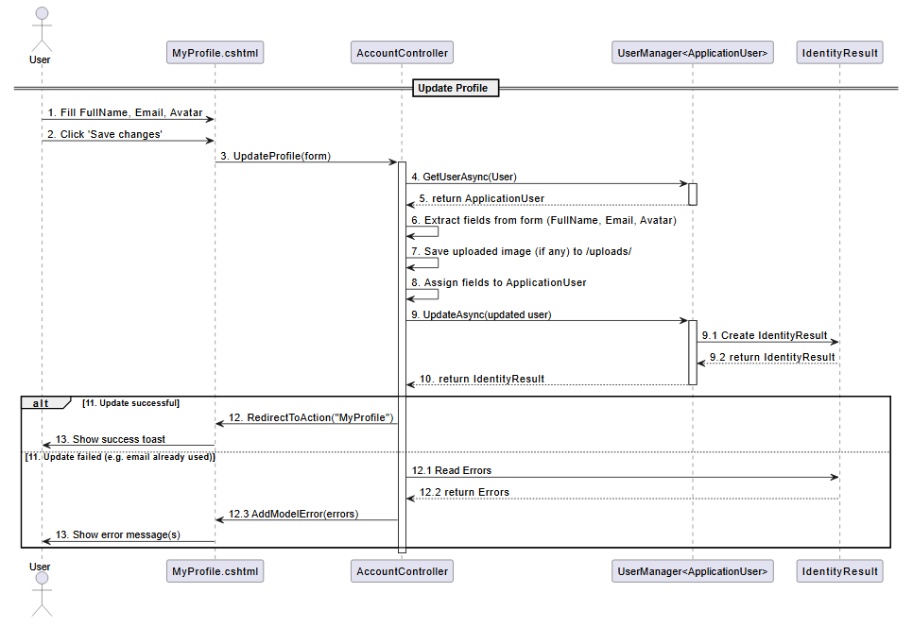

### d. Database Queries

UPDATE AspNetUsers

SET

FullName = @FullName,

Email = @Email,

ProfilePicturePath = @ProfilePicturePath

WHERE Id = @UserId;

## 

## 10. View User Accounts

**Use Case:** UC-10: View User Accounts

### a. Class Diagram

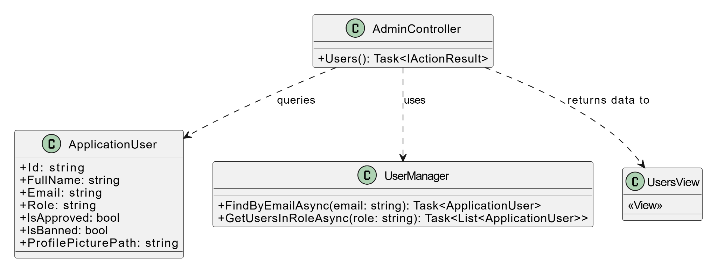

### b. Class Specifications

#### AdminController

| **No** | **Method** | **Description** |
| --- | --- | --- |
| 1 | Users() | Retrieves a list of all users from the system and returns it to the user accounts view. |

#### UserManager

| **No** | **Method** | **Description** |
| --- | --- | --- |
| 1 | GetUsersInRoleAsync(string role) | Asynchronously retrieves users assigned to the specified role. |
| 2 | FindByEmailAsync(string email) | Looks up a user account by their email address. |

### c. Sequence Diagram

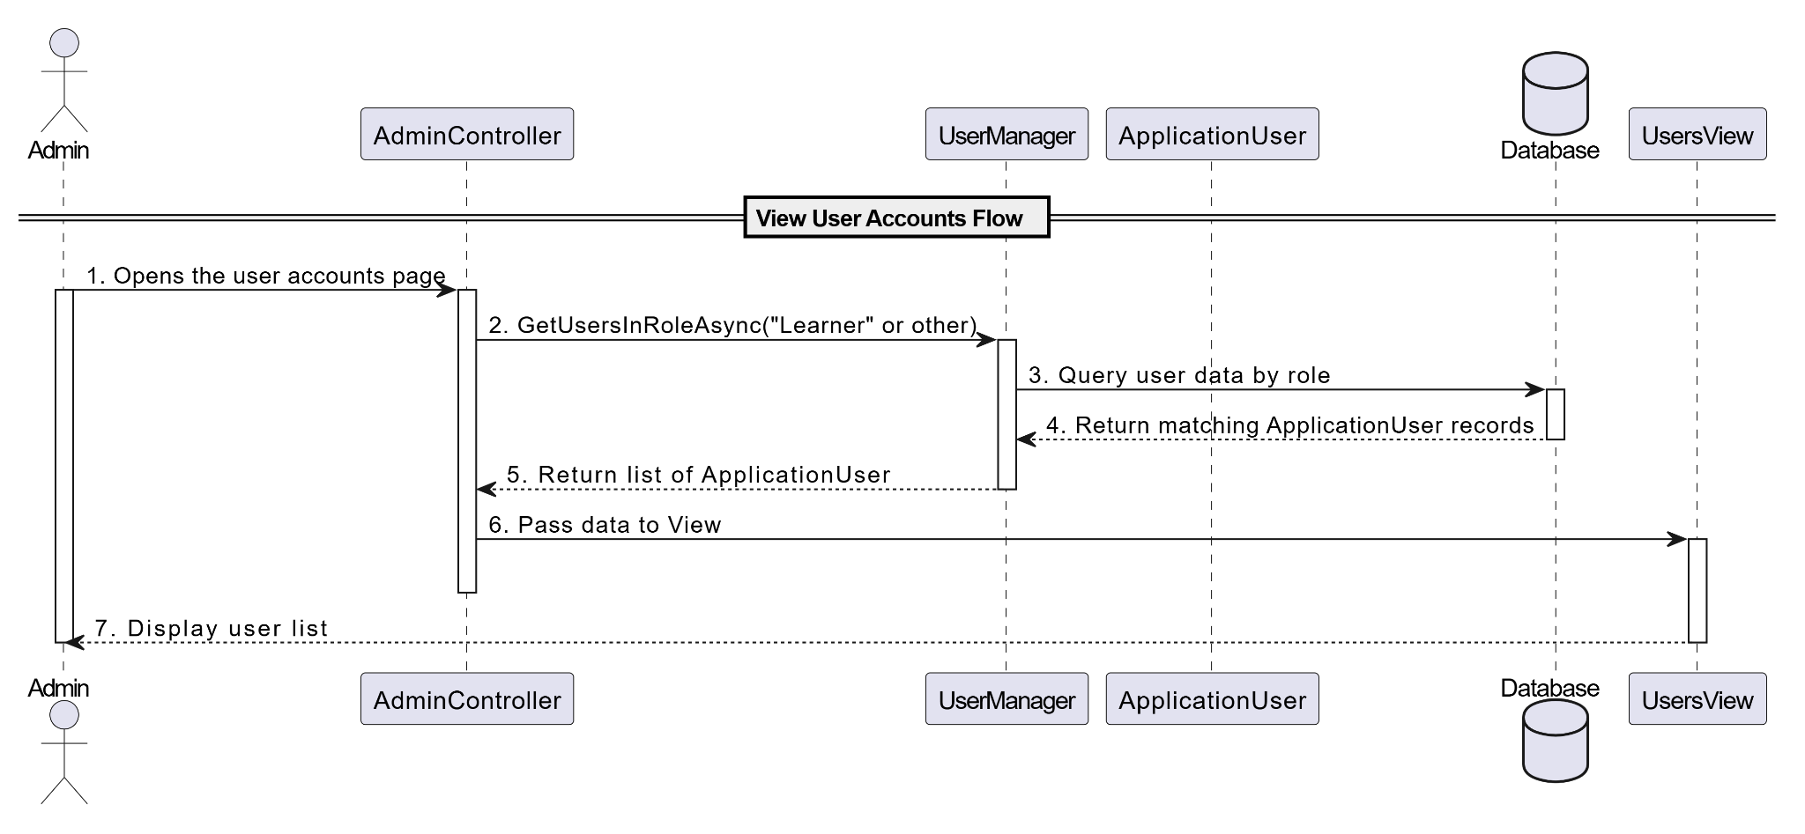

### d. Database Queries

SELECT

Id,

FullName,

Email,

Role,

IsApproved,

IsBanned,

ProfilePicturePath

FROM AspNetUsers

ORDER BY Role, FullName;

## 

## 11. Create Account

**Use Case:** UC-10a: Create Account

### a. Class Diagram

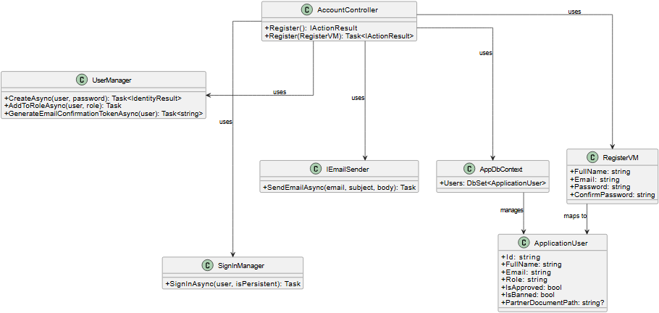

### b. Class Specifications

#### AccountController

| **No** | **Method** | **Description** |
| --- | --- | --- |
| 01 | Register() | Returns the registration form view |
| 02 | Register(RegisterVM) | Validates input, creates new user, assigns role, sends confirmation email |

#### RegisterVM

| **No** | **Field** | **Description** |
| --- | --- | --- |
| 01 | FullName | Full name of the registering user |
| 02 | Email | User's email address |
| 03 | Password | Plain password (validated before hashing) |
| 04 | ConfirmPassword | Must match Password |

#### ApplicationUser

| **No** | Field | **Description** |
| --- | --- | --- |
| 01 | Role | Default to “Learner” unless otherwise specified |
| 02 | IsApproved | For Partner/Admin approval flow |
| 03 | IsBanned | Used to block access |

#### UserDao

| **No** | **Method** | **Description** |
| --- | --- | --- |
| 01 | CreateAsync | Creates the IdentityUser with hashed password |
| 02 | AddToRoleAsync | Assigns user to a role (e.g., Learner) |
| 03 | GenerateEmailConfirmationTokenAsync | Generates token for email verification |

### 

### c. Sequence Diagram

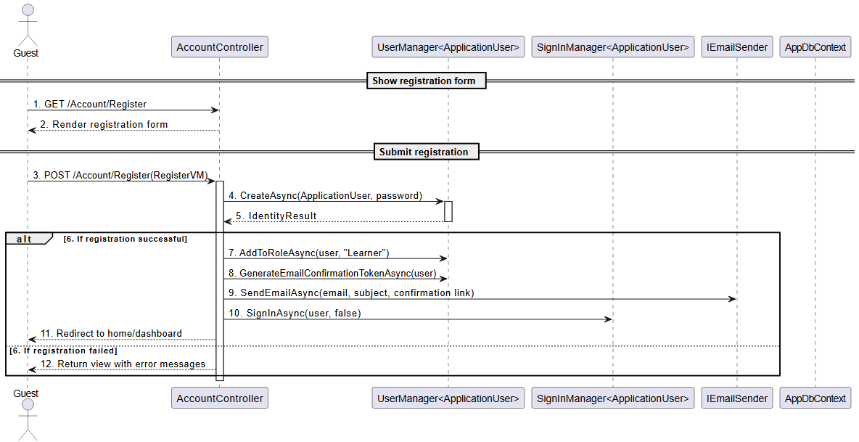

### d. Database Queries

-- 1. Insert new user into AspNetUsers

INSERT INTO AspNetUsers (FullName, Email, PasswordHash, Role, IsApproved, IsBanned)

VALUES (@FullName, @Email, @PasswordHash, 'Learner', 1, 0);

-- 2. Insert user-role relationship

INSERT INTO AspNetUserRoles (UserId, RoleId)

VALUES (@UserId, (SELECT Id FROM AspNetRoles WHERE Name = 'Learner'));

## 

## 12. Edit Account

**Use Case:** UC-10b: Edit Account

### a. Class Diagram

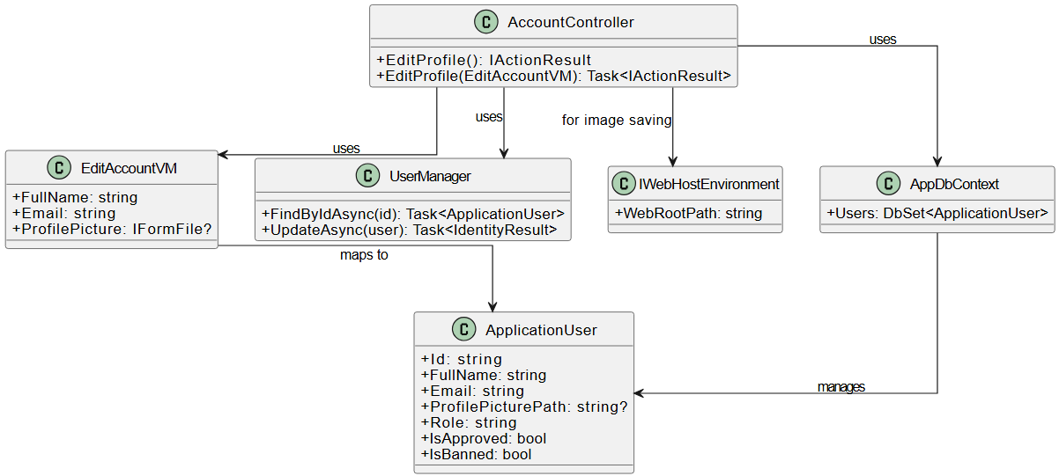

### b. Class Specifications

#### AccountController

| **No** | **Method** | **Description** |
| --- | --- | --- |
| 01 | EditProfile() | Loads the current user's data and returns the edit view |
| 02 | EditProfile(EditAccountVM) | Validates and updates profile info, including profile picture if provided |

#### EditAccountVM

| **No** | **Field** | **Description** |
| --- | --- | --- |
| 01 | FullName | New full name |
| 02 | Email | New email |
| 03 | ProfilePicture | Optional new profile picture (IFormFile) |

#### UserManager

| **No** | **Method** | **Description** |
| --- | --- | --- |
| 01 | FindByIdAsync | Gets the user from DB |
| 02 | UpdateAsync | Applies updates to user record |

### 

### c. Sequence Diagram

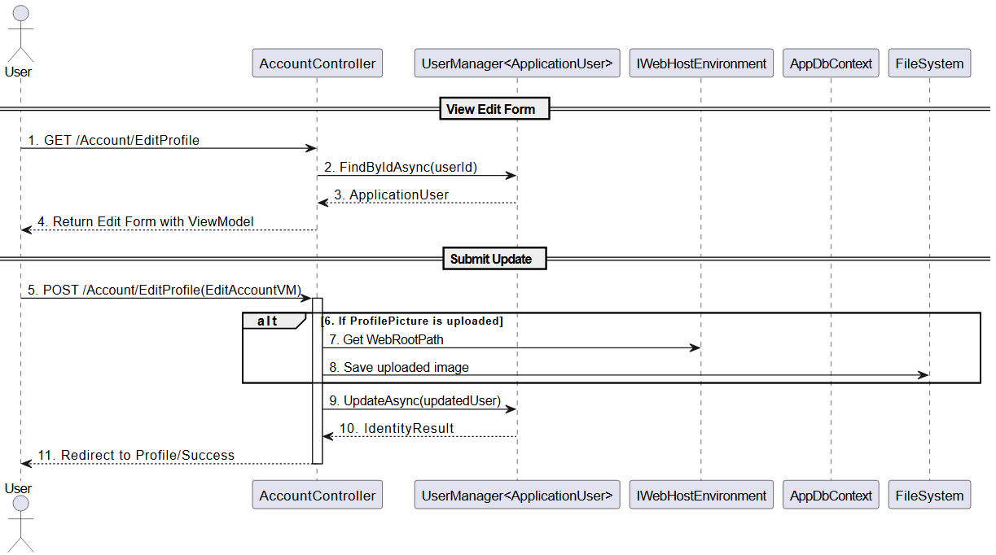

### 

### d. Database Queries

SELECT * FROM AspNetUsers WHERE Id = @UserId;

UPDATE AspNetUsers

SET FullName = @FullName,

Email = @Email,

ProfilePicturePath = @Path

WHERE Id = @UserId;

## 

## 13. Delete Account

**Use Case:** UC-10c: Delete Account

### a. Class Diagram

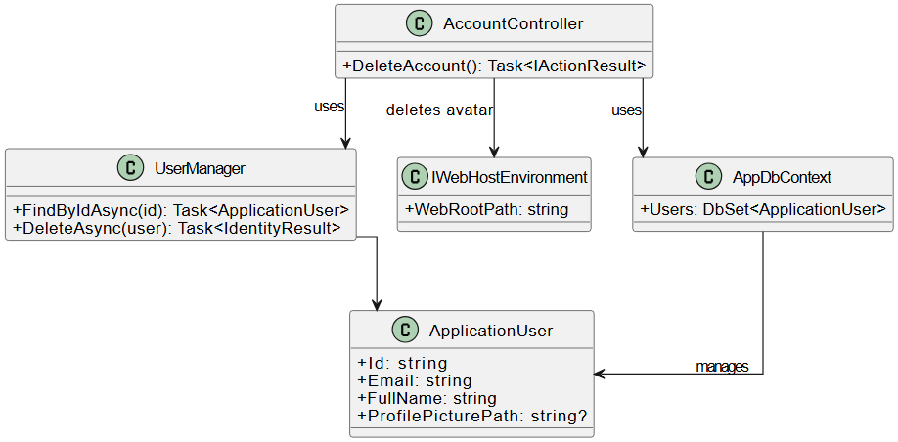

### b. Class Specifications

#### AccountController

| **No** | **Method** | **Description** |
| --- | --- | --- |
| 01 | DeleteAccount() | Loads current user → deletes profile pic (if any) → deletes user from DB |

#### UserManager

| **No** | **Method** | **Description** |
| --- | --- | --- |
| 01 | FindByIdAsync | Finds user by current session |
| 02 | DeleteAsync | Removes user from identity system |

### 

### c. Sequence Diagram

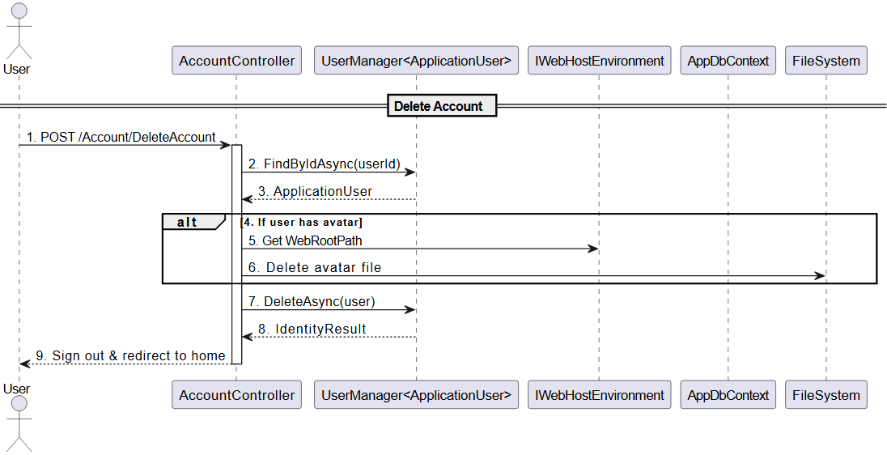

### d. Database Queries

-- 1. Find user

SELECT * FROM AspNetUsers WHERE Id = @UserId;

-- 2. Delete user (cascades if FK exists)

DELETE FROM AspNetUsers WHERE Id = @UserId;

-- 3. (Optional) Manually delete related records if not cascading

-- DELETE FROM Orders WHERE UserId = @UserId;

-- DELETE FROM Enrollments WHERE LearnerId = @UserId;

## 

## 14. View Requested Partner List

**Use Case:** UC-11: View Requested Partner List

### a. Class Diagram

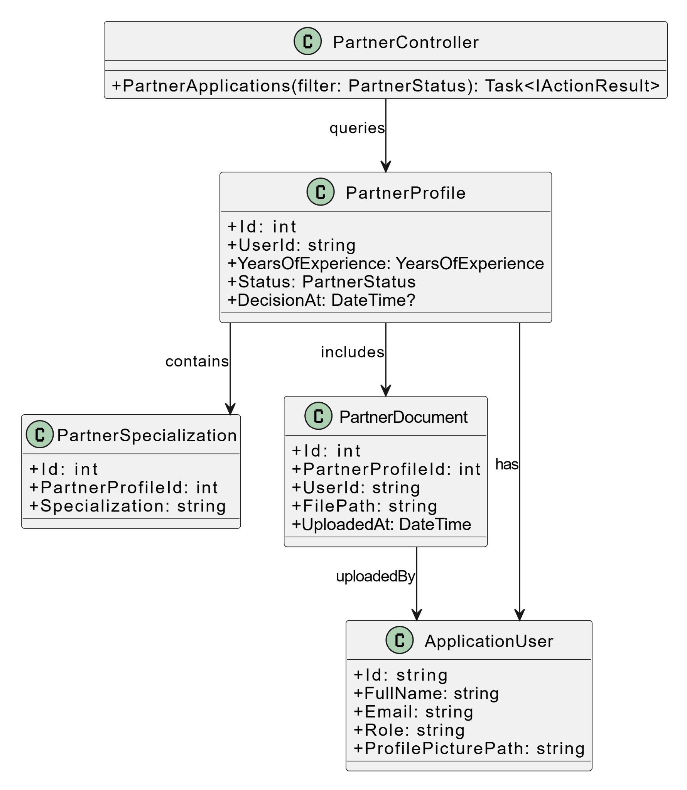

### b. Class Specifications

PartnerController

| **No** | **Method** | **Description** |
| --- | --- | --- |
| 1 | PartnerApplications(filter: PartnerStatus): Task<IActionResult> | Retrieves a list of partner applications filtered by status (e.g., Pending, Approved) for admin review. |

PartnerProfile

| Field | Description |
| --- | --- |
| Id | Primary key |
| UserId | Foreign key to ApplicationUser |
| Status | Enum: Pending, Approved, Rejected |
| SubmittedAt | Timestamp when profile was submitted |

### c. Sequence Diagram

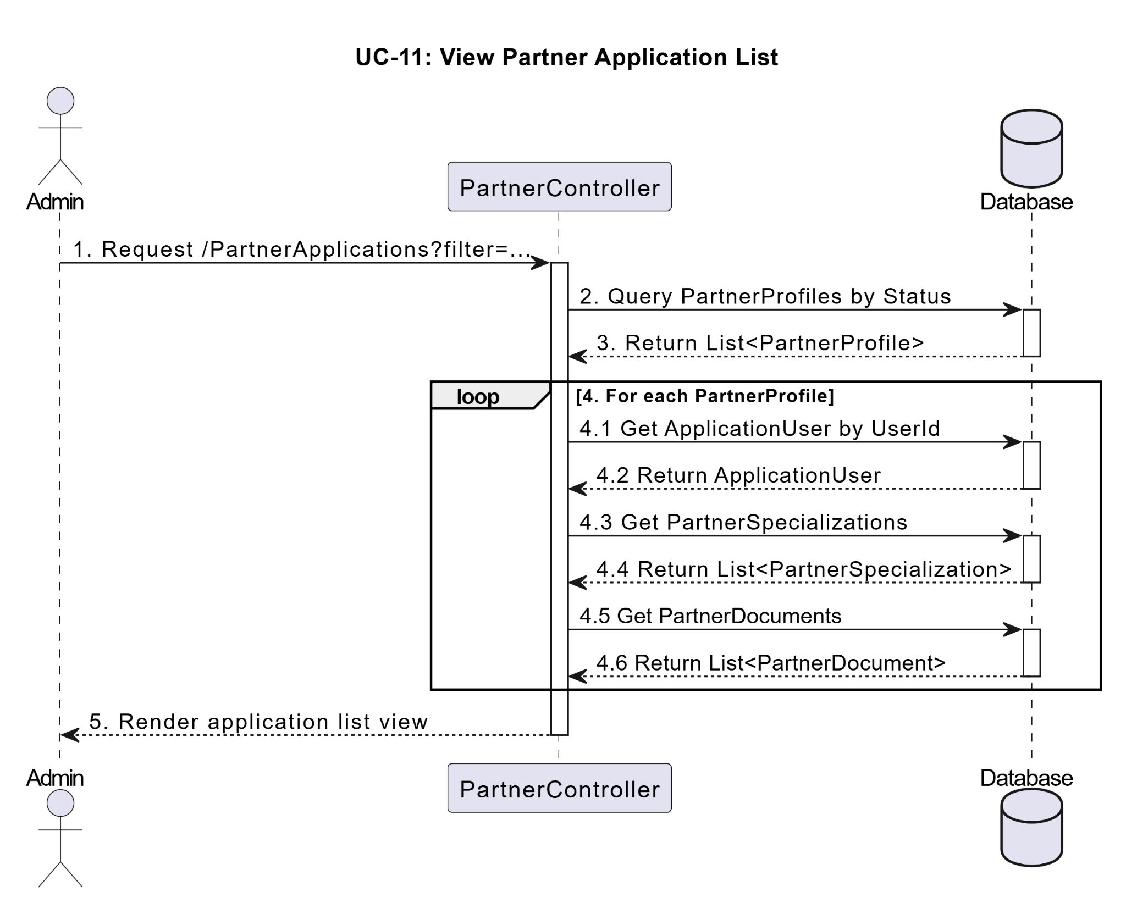

### d. Database Queries

SELECT * FROM PartnerProfiles

JOIN AspNetUsers ON PartnerProfiles.UserId = AspNetUsers.Id

WHERE PartnerProfiles.Status = 'Pending';

## 15. View Requested Partner’s Documents

**Use Case:** UC-12: View Requested Partner’s Documents

### a. Class Diagram

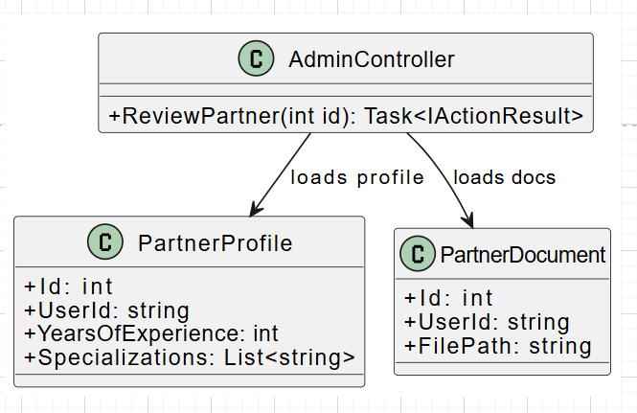

### b. Class Specifications

AdminController

| **No** | **Method** | **Description** |
| --- | --- | --- |
| 1 | ReviewPartner(id) | Load full profile + documents for specific partner |

PartnerDocument

| Field | Description |
| --- | --- |
| Id | Document ID |
| UserId | FK to ApplicationUser |
| FilePath | File URL/path |

### c. Sequence Diagram

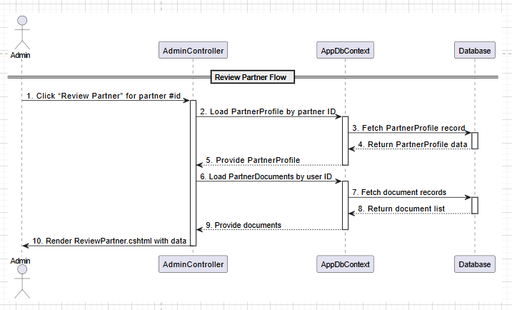

### d. Database Queries

SELECT * FROM PartnerProfiles WHERE Id = ?;

SELECT * FROM PartnerDocuments WHERE UserId = ?;

## 16. Approve Partner

**Use Case:** UC-13: Approve Partner

### a. Class Diagram

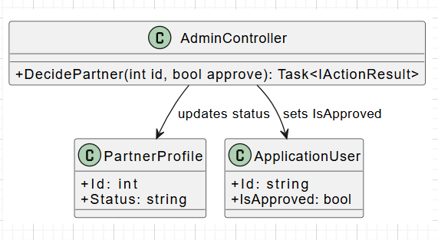

### b. Class Specifications

AdminController

| No | Method | Description |
| --- | --- | --- |
| 1 | DecidePartner(id, approve) | Approve or reject a partner application |

### 

### c. Sequence Diagram

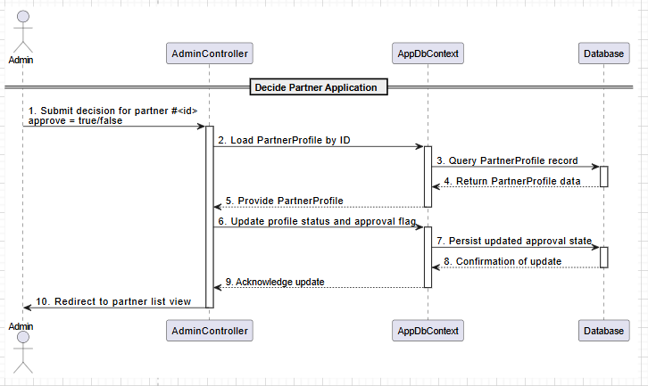

### d. Database Queries

-- Update approval status

UPDATE PartnerProfiles

SET Status = 'Approved' -- or 'Rejected'

WHERE Id = ?;

UPDATE AspNetUsers

SET IsApproved = TRUE -- or FALSE

WHERE Id = ?;

## 

## 17. Reset User Password (Admin)

**Use Case:** UC-14: Reset User Password

### a. Class Diagram

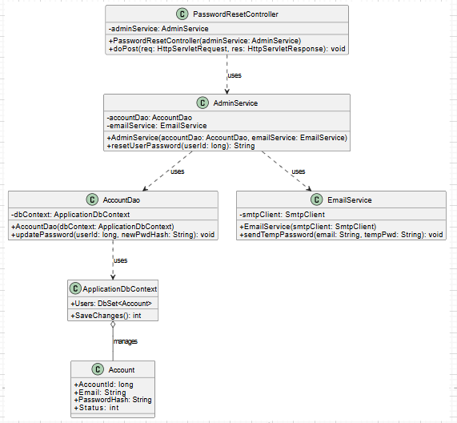

### b. Class Specifications

#### PasswordResetController

| **No** | **Method** | **Description** |
| --- | --- | --- |
| 01 | void doPost(HttpServletRequest req, HttpServletResponse res) | 1. Reads userId from request parameters (e.g. req.getParameter("userId")).  2. Calls adminService.resetUserPassword(userId).  3. Adds a success message.  4. Redirects to the user list page. |

#### AdminService

| **No** | **Method** | **Description** |
| --- | --- | --- |
| 01 | void resetUserPassword(long userId) | 1. Generates a secure temporary password.  2. Hashes it.  3. Calls accountDao.updatePassword(userId, hashedPwd).  4. Retrieves user email.  5. Calls emailService.sendTempPassword(email, tempPwd). |

#### AccountDao

| **No** | **Method** | **Description** |
| --- | --- | --- |
| 01 | void updatePassword(long id, String pwd) | UPDATE Account SET password = ? WHERE account_id = ? AND status = 1 |

#### EmailService

| **No** | **Method** | **Description** |
| --- | --- | --- |
| 01 | void sendTempPassword(String email, String tempPwd) | Sends an email containing the temporary password. |

### 

#### EmailService

| **No** | **Method** | **Description** |
| --- | --- | --- |
| 01 | void sendTempPassword(String email, String tempPwd) | Sends an email containing the temporary password. |

### 

### 

### 

### c. Sequence Diagram

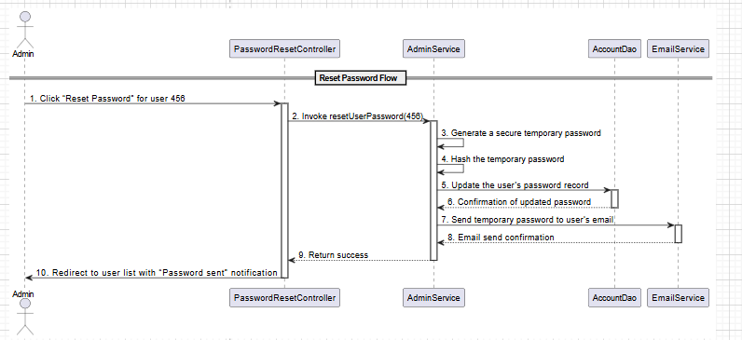

### d. Database Queries

UPDATE Account

SET password = :newPassword

WHERE account_id = :userId

AND status = 1;

## 

## 18. View Classrooms List

**Use Case:** UC-15: View Classrooms List

### a. Class Diagram

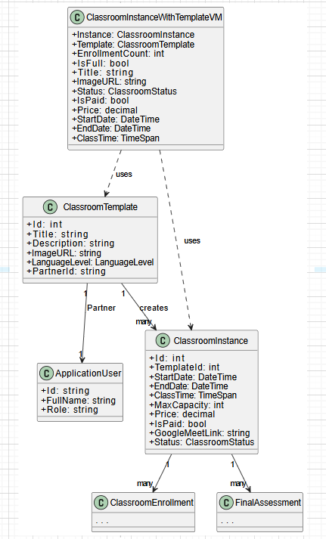

### b. Class Specifications

ClassroomInstancesController

| **No** | **Method** | **Description** |
| --- | --- | --- |
| 1 | Index(page: int, pageSize: int): Task<IActionResult> | Loads a paginated list of classroom instances with their templates and enrollment counts for display in the view. |

### c. Sequence Diagram

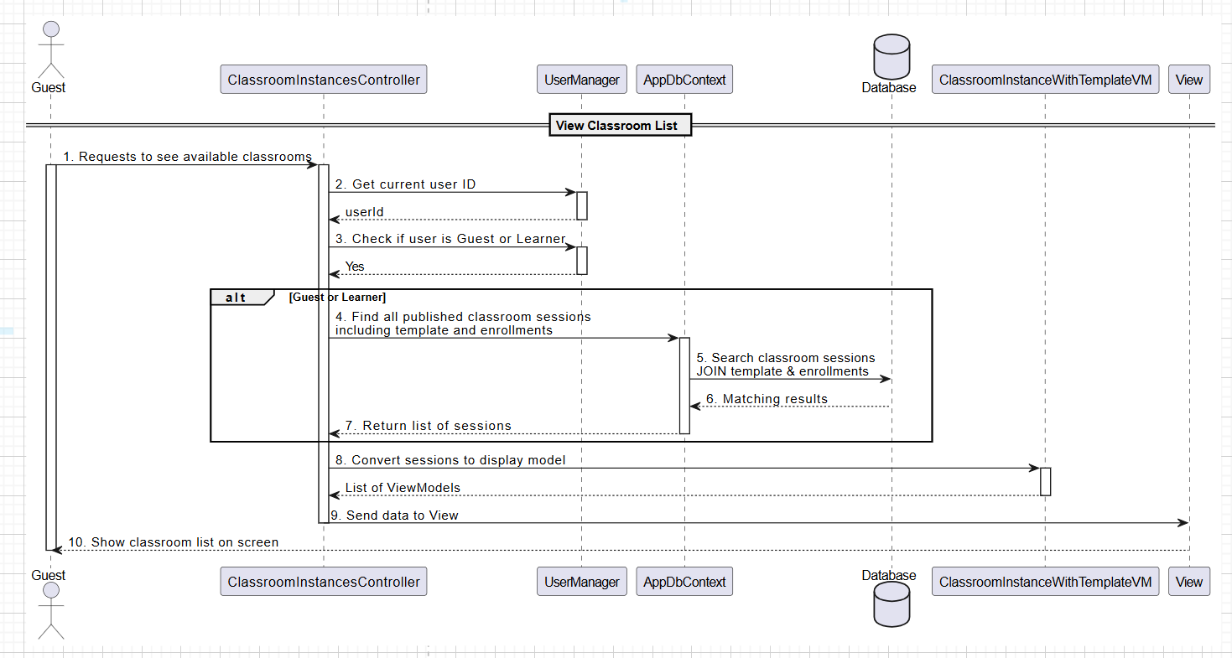

### d. Database Queries

SELECT classroom_id, title, description, schedule, partner_id  
 FROM Classrooms  
 WHERE status = 'ACTIVE'  
 ORDER BY schedule

## 19. Search a Classroom

**Use Case:** UC-16: Search a Classroom

### a. Class Diagram

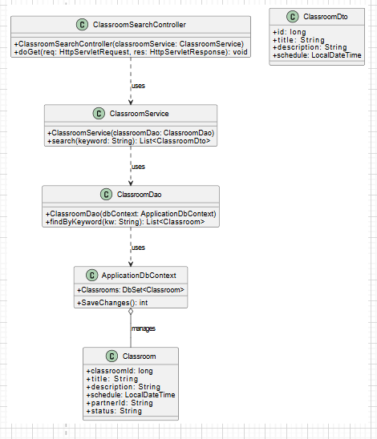

### b. Class Specifications

ClassroomSearchController

| **No** | **Method** | **Description** |
| --- | --- | --- |
| 01 | void doGet(HttpServletRequest req, HttpServletResponse res) | 1. Reads q parameter from request (e.g. req.getParameter("q")).  2. Calls classroomService.search(q).  3. Stores the returned list under "results" attribute.  4. Forwards to searchResults.jsp. |

ClassroomService

| **No** | **Method** | **Description** |
| --- | --- | --- |
| 01 | List<ClassroomDto> search(String keyword) | 1. Sanitizes or trims the keyword.  2. Calls classroomDao.findByKeyword(keyword).  3. Maps each Classroom entity to a ClassroomDto.  4. Returns the list of DTOs. |

ClassroomDao

| **No** | **Method** | **Description** |
| --- | --- | --- |
| 01 | List<Classroom> findByKeyword(String kw) | Executes a query to fetch active classrooms whose title or description contains the keyword, ordered by schedule. |

### c. Sequence Diagram

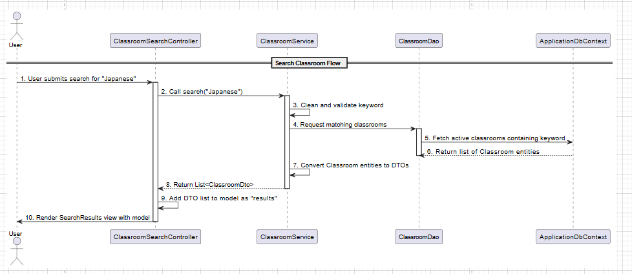

### d. Database Queries

SELECT classroom_id,

title,

description,

schedule,

partner_id

FROM Classrooms

WHERE status = 'ACTIVE'

AND (title LIKE '%' || :keyword || '%'

OR description LIKE '%' || :keyword || '%')

ORDER BY schedule;

## 20. View Classroom Details

**Use Case:** UC-17: View Classroom Details

### a. Class Diagram

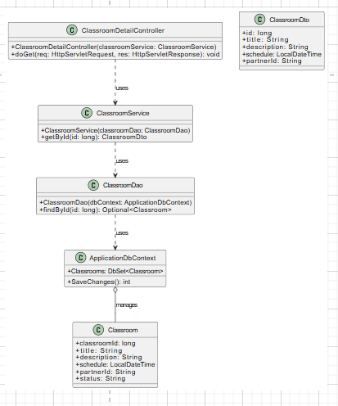

### b. Class Specifications

ClassroomDetailController

| **No** | **Method** | **Description** |
| --- | --- | --- |
| 01 | void doGet(HttpServletRequest req, HttpServletResponse res) | 1. Reads id from request (e.g. Long.parseLong(req.getParameter("id"))).  2. Calls classroomService.getById(id).  3. Sets "classroom" attribute.  4. Forwards to classroomDetail.cshtml. |

ClassroomService

| **No** | **Method** | **Description** |
| --- | --- | --- |
| 01 | ClassroomDto getById(long id) | 1. Invokes classroomDao.findById(id).  2. If empty, throws NotFoundException (404).  3. Maps the found Classroom to ClassroomDto.  4. Returns the DTO. |

ClassroomDao

| **No** | **Method** | **Description** |
| --- | --- | --- |
| 01 | Optional<Classroom> findById(long id) | SELECT * FROM Classrooms WHERE classroom_id = ? AND status = 'ACTIVE' |

### c. Sequence Diagram

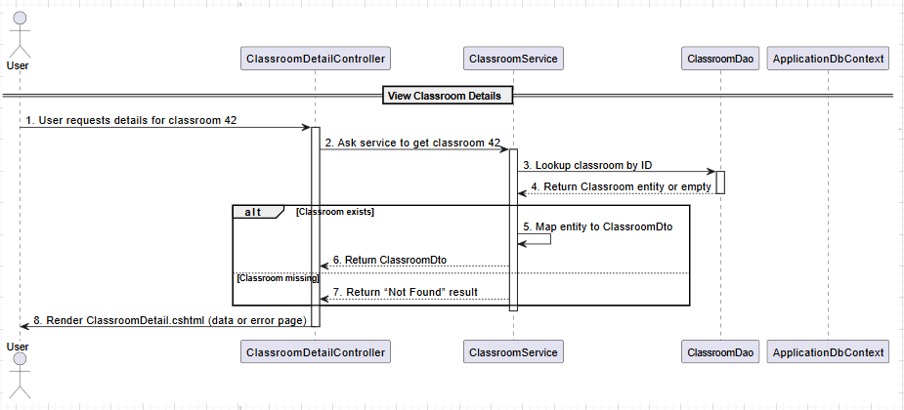

### 

### d. Database Queries

SELECT classroom_id,

title,

description,

schedule,

partner_id

FROM Classrooms

WHERE classroom_id = :id

AND status = 'ACTIVE';

## 

## 21. View Joined Classrooms

**Use Case:** UC-18: View Joined Classrooms

### a. Class Diagram

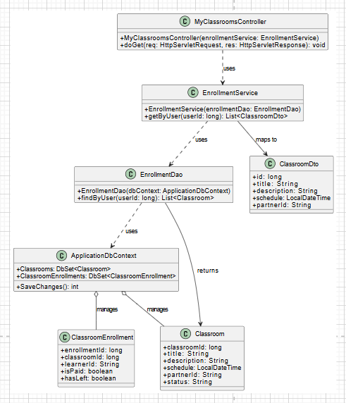

### 

### b. Class Specifications

#### MyClassroomsController

| **No** | **Method** | **Description** |
| --- | --- | --- |
| 01 | void doGet(HttpServletRequest req, HttpServletResponse res) | 1. Retrieves userId from session (e.g. req.getSession().getAttribute("userId")).  2. Calls enrollmentService.getByUser(userId).  3. Sets "myClasses" attribute with returned list.  4. Forwards to myClassrooms.cshtml. |

#### EnrollmentService

| **No** | **Method** | **Description** |
| --- | --- | --- |
| 01 | List<ClassroomDto> getByUser(long uid) | 1. Calls enrollmentDao.findByUser(userId).  2. Maps each Classroom to ClassroomDto.  3. Returns the list of DTOs. |

#### EnrollmentDao

| **No** | **Method** | **Description** |
| --- | --- | --- |
| 01 | List<Classroom> findByUser(long uid) | SELECT c.* FROM Classrooms c JOIN ClassroomEnrollment e ON c.id=e.classroom_id WHERE e.learner_id=? |

### 

### c. Sequence Diagram

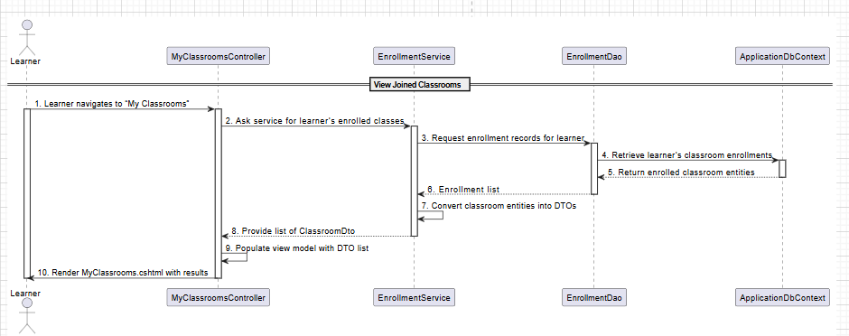

### d. Database Queries

SELECT c.classroom_id,

c.title,

c.description,

c.schedule,

c.partner_id

FROM Classrooms c

JOIN ClassroomEnrollment e

ON c.classroom_id = e.classroom_id

WHERE e.learner_id = :userId;

## 

## 22. View Classroom Dashboard

**Use Case:** UC-19: View Classroom Dashboard

### a. Class Diagram

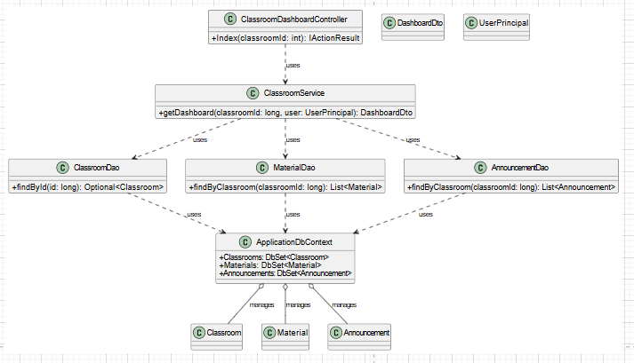

### b. Class Specifications

#### ClassroomDashboardController

| **No** | **Method** | **Description** |
| --- | --- | --- |
| 01 | void doGet(HttpServletRequest req, HttpServletResponse res) | 1. Reads classroomId from route or query string.  2. Obtains current UserPrincipal (via User).  3. Calls classroomService.getDashboard(classroomId, user).  4. Passes returned DTO into the view: return View("ClassroomDashboard", dto). |

#### 

#### ClassroomService

| **No** | **Method** | **Description** |
| --- | --- | --- |
| 01 | DashboardDto getDashboard(long cid, UserPrincipal user) | 1. Verifies that user has access to this classroom (role or enrollment).  2. Calls classroomDao.findById(cid); if missing or inactive, throws NotFoundException.  3. Calls materialDao.findByClassroom(cid).  4. Calls announcementDao.findByClassroom(cid).  5. Maps entities into DashboardDto and returns it. |

#### ClassroomDao

| **No** | **Method** | **Description** |
| --- | --- | --- |
| 01 | Optional<Classroom> findById(long id) | SELECT * FROM Classrooms WHERE classroom_id=? AND status='ACTIVE' |

### c. Sequence Diagram

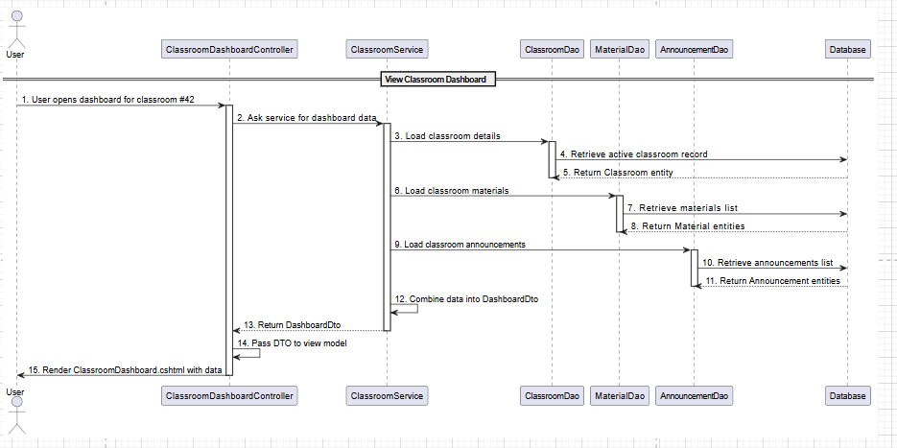

### 

### d. Database Queries

-- 1. Load classroom

SELECT *

FROM Classrooms

WHERE classroom_id = :id

AND status = 'ACTIVE';

-- 2. Load materials

SELECT *

FROM Materials

WHERE classroom_id = :id

ORDER BY sequence;

-- 3. Load announcements

SELECT *

FROM Announcements

WHERE classroom_id = :id

ORDER BY posted_at DESC;

## 

## 23. Join Video Call

**Use Case:** UC-20: Join Video Call

### a. Class Diagram

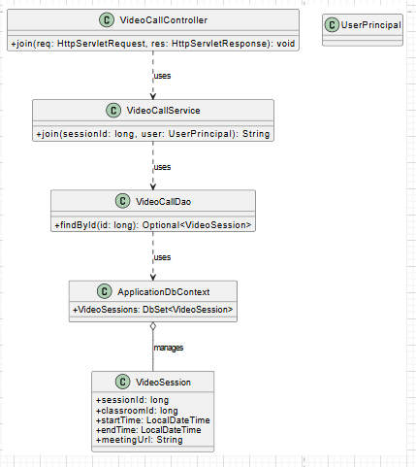

### b. Class Specifications

#### VideoCallController

| **No** | **Method** | **Description** |
| --- | --- | --- |
| 01 | void doGet(HttpServletRequest req, HttpServletResponse res) | 1. Reads sessionId from query (e.g. Long.parseLong(req.getParameter("sid"))).  2. Calls videoCallService.join(sessionId, currentUser).  3. If URL returned, sends a redirect; otherwise forwards to an error page. |

#### VideoCallService

| **No** | **Method** | **Description** |
| --- | --- | --- |
| 01 | String join(long sessionId, UserPrincipal user) | 1. Validates that user is enrolled and session is active.  2. Calls videoCallDao.findById(sessionId).  3. If present, returns its meetingUrl; otherwise throws an exception. |

#### VideoCallDao

| **No** | **Method** | **Description** |
| --- | --- | --- |
| 01 | Optional<VideoSession> findById(long id) | SELECT * FROM VideoSessions WHERE session_id=? AND start <= now() <= end |

### c. Sequence Diagram

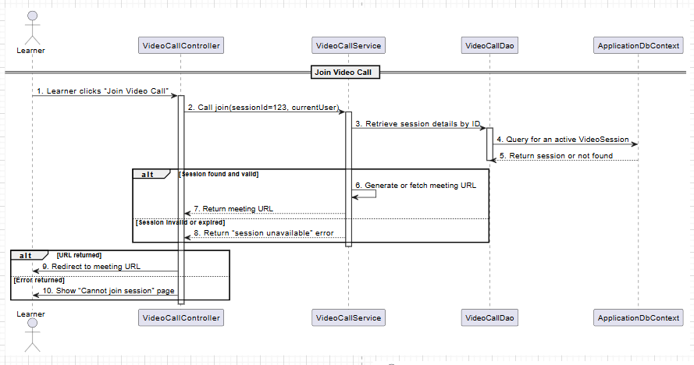

### 

### d. Database Queries

SELECT session_id,

classroom_id,

start_time,

end_time,

meeting_url

FROM VideoSessions

WHERE session_id = :sessionId

AND CURRENT_TIMESTAMP BETWEEN start_time AND end_time;

## 

## 24. View Managed Classrooms

**Use Case:** UC-21: View Managed Classrooms

### a. Class Diagram

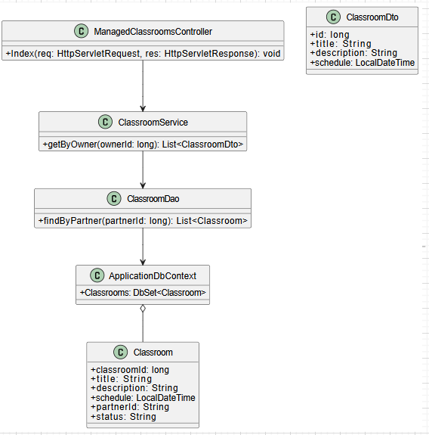

### 

### b. Class Specifications

#### ManagedClassroomsController

| **No** | **Method** | **Description** |
| --- | --- | --- |
| 01 | void doGet(HttpServletRequest req, HttpServletResponse res) | 1. Retrieves userId from session (req.getSession().getAttribute("userId")).  2. Calls classroomService.getByOwner(userId).  3. Sets "myOwned" attribute.  4. Forwards to managedClassrooms.cshtml. |

#### ClassroomService

| **No** | **Method** | **Description** |
| --- | --- | --- |
| 01 | List<ClassroomDto> getByOwner(long ownerId) | 1. Calls classroomDao.findByPartner(ownerId).  2. Maps each Classroom entity to ClassroomDto.  3. Returns the DTO list. |

#### ClassroomDao

| **No** | **Method** | **Description** |
| --- | --- | --- |
| 01 | List<Classroom> findByPartner(long pid) | SELECT * FROM Classrooms WHERE partner_id=? AND status='ACTIVE' |

### 

### c. Sequence Diagram

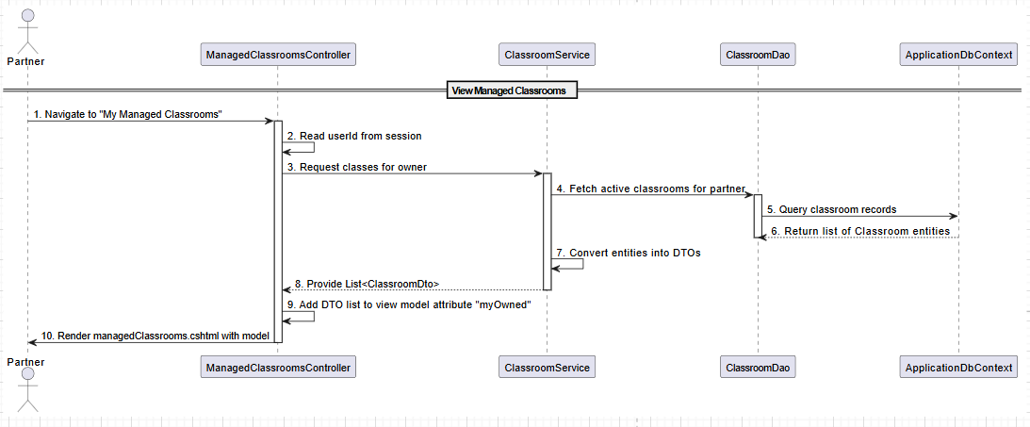

### d. Database Queries

SELECT classroom_id,

title,

description,

schedule

FROM Classrooms

WHERE partner_id = :partnerId

AND status = 'ACTIVE';

## 

## 25. Create a Classroom

**Use Case:** UC-21a: Create a Classroom

### a. Class Diagram

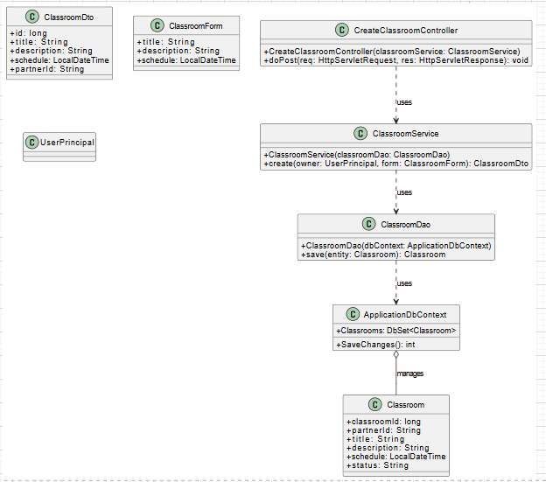

### b. Class Specifications

#### CreateClassroomController

| **No** | **Method** | **Description** |
| --- | --- | --- |
| 01 | void doPost(HttpServletRequest req, HttpServletResponse res) | 1. Reads title, description, schedule from req.getParameter or via data binding.  2. Constructs ClassroomForm form.  3. Calls classroomService.create(currentUser, form).  4. Redirects to “/my-classrooms”. |

#### ClassroomService

| **No** | **Method** | **Description** |
| --- | --- | --- |
| 01 | ClassroomDto create(UserPrincipal owner, ClassroomForm f) | 1. Validates that owner has Partner role.  2. Constructs a new Classroom entity using data from form and owner.getId().  3. Calls classroomDao.save(entity).  4. Maps saved entity to ClassroomDto and returns it. |

#### ClassroomDao

| **No** | **Method** | **Description** |
| --- | --- | --- |
| 01 | Classroom save(Classroom entity) | INSERT INTO Classrooms (partner_id,title,description,schedule,status) VALUES (?,?,?,?,'ACTIVE') |

### 

### c. Sequence Diagram

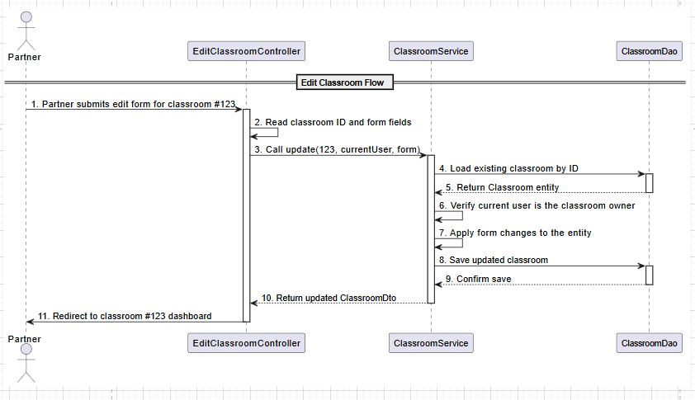

### d. Database Queries

INSERT INTO Classrooms

(partner_id, title, description, schedule, status)

VALUES

(:partnerId, :title, :description, :schedule, 'ACTIVE');

## 

## 26. Edit a Classroom

**Use Case:** UC-21b: Edit a Classroom

### a. Class Diagram

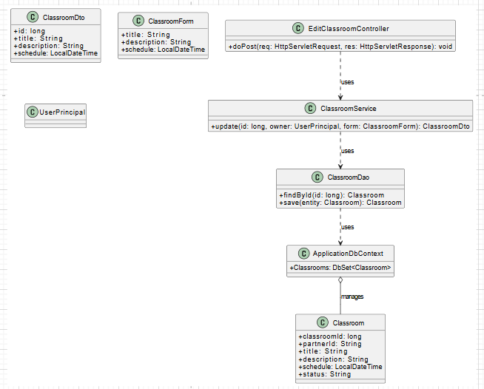

### b. Class Specifications

#### EditClassroomController

| **No** | **Method** | **Description** |
| --- | --- | --- |
| 01 | void doPost(HttpServletRequest req, HttpServletResponse res) | 1. Reads id and updated fields from request (e.g. req.getParameter).  2. Builds ClassroomForm form.  3. Calls classroomService.update(id, currentUser, form).  4. Redirects to /classrooms/{id}/dashboard. |

#### ClassroomService

| **No** | **Method** | **Description** |
| --- | --- | --- |
| 01 | ClassroomDto update(long id, UserPrincipal owner, ClassroomForm f) | 1. Calls classroomDao.findById(id).  2. Verifies that entity.partnerId == owner.getId().  3. Applies changes from form to entity.  4. Calls classroomDao.save(entity).  5. Maps saved entity to ClassroomDto and returns. |

#### ClassroomDao

| **No** | **Method** | **Description** |
| --- | --- | --- |
| 01 | Classroom findById(long id) | SELECT * FROM Classrooms WHERE classroom_id=? |
| 02 | Classroom save(Classroom entity) | UPDATE Classrooms SET title=?,description=?,schedule=? WHERE id=? |

### 

### c. Sequence Diagram

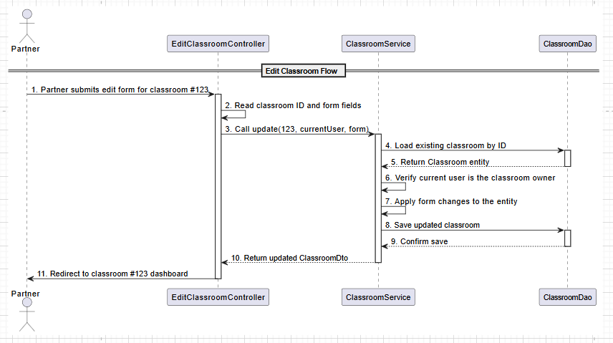

### d. Database Queries

SELECT *

FROM Classrooms

WHERE classroom_id = :id

;

UPDATE Classrooms

SET title = :title,

description = :description,

schedule = :schedule

WHERE classroom_id = :id

;

## 

## 27. Delete a Classroom

**Use Case:** UC-21c: Delete a Classroom

### a. Class Diagram

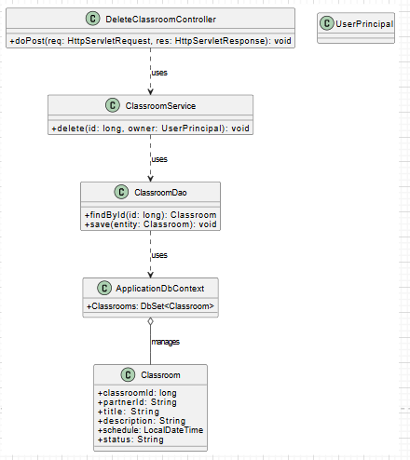

### b. Class Specifications

#### DeleteClassroomController

| **No** | **Method** | **Description** |
| --- | --- | --- |
| 01 | void doPost(HttpServletRequest req, HttpServletResponse res) | Reads id; calls ClassroomService.delete(id, user); redirects to “My Classrooms.” |

#### 

#### ClassroomService

| **No** | **Method** | **Description** |
| --- | --- | --- |
| 01 | void delete(long id, UserPrincipal owner) | Loads via DAO, checks owner, sets status='INACTIVE', saves via DAO. |

#### ClassroomDao

| **No** | **Method** | **Description** |
| --- | --- | --- |
| 01 | Classroom findById(long id) | SELECT * FROM Classrooms WHERE classroom_id=? |
| 02 | void save(Classroom entity) | UPDATE Classrooms SET status='INACTIVE' WHERE classroom_id=? |

### c. Sequence Diagram

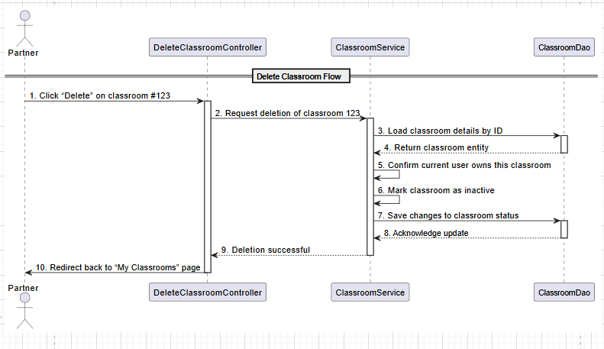

### d. Database Queries

-- Load existing classroom

SELECT *

FROM Classrooms

WHERE classroom_id = :id

;

-- Mark as inactive

UPDATE Classrooms

SET status = 'INACTIVE'

WHERE classroom_id = :id

;

## 

## 28. View Enrolled Learners

**Use Case:** UC-22: View Enrolled Learners

### a. Class Diagram

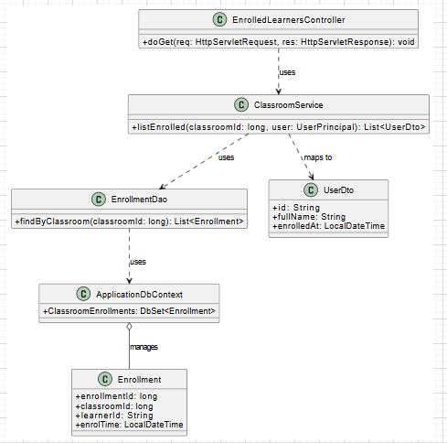

### b. Class Specifications

#### EnrolledLearnersController

| **No** | **Method** | **Description** |
| --- | --- | --- |
| 01 | void doGet(HttpServletRequest req, HttpServletResponse res) | 1. Reads classroomId from request (e.g. Long.parseLong(req.getParameter("classroomId"))).  2. Calls classroomService.listEnrolled(classroomId, currentUser).  3. Stores the returned list as "learners" attribute.  4. Forwards to EnrolledLearners.cshtml. |

#### ClassroomService

| **No** | **Method** | **Description** |
| --- | --- | --- |
| 01 | List<UserDto> listEnrolled(long cid, UserPrincipal user) | 1. Verifies that user owns the classroom (throws if not).  2. Calls enrollmentDao.findByClassroom(cid).  3. Maps each Enrollment to UserDto (id, fullName, enrolledAt).  4. Returns the DTO list. |

#### EnrollmentDao

| **No** | **Method** | **Description** |
| --- | --- | --- |
| 01 | List<Enrollment> findByClassroom(long classroomId) | Executes a query to retrieve all enrollments for the given classroom. |

### c. Sequence Diagram

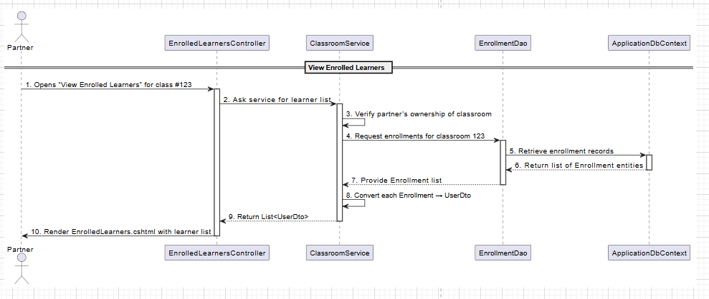

### d. Database Queries

SELECT learner_id,

enrol_time

FROM ClassroomEnrollment

WHERE classroom_id = :classroomId;

## 

## 29. Host a Video Call

**Use Case:** UC-23: Host a Video Call

### a. Class Diagram

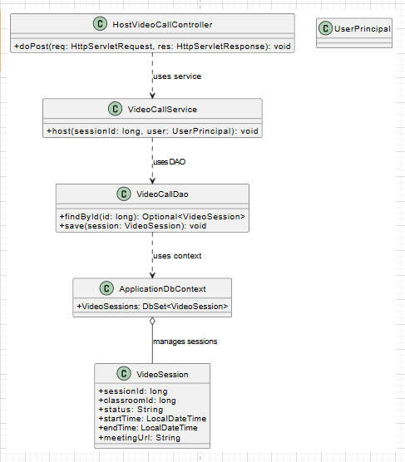

### b. Class Specifications

#### HostVideoCallController

| **No** | **Method** | **Description** |
| --- | --- | --- |
| 01 | void doPost(HttpServletRequest req, HttpServletResponse res) | 1. Reads sessionId from request (e.g. Long.parseLong(req.getParameter("sessionId"))).  2. Calls videoCallService.host(sessionId, currentUser).  3. Writes JSON { success: true } or error. |

#### VideoCallService

| **No** | **Method** | **Description** |
| --- | --- | --- |
| 01 | void host(long sid, UserPrincipal user) | 1. Calls videoCallDao.findById(sid).  2. Verifies that user is the partner owner of that session.  3. Sets session.status = "IN_PROGRESS" and session.startTime = now().  4. Calls videoCallDao.save(session). |

#### VideoCallDao

| **No** | **Method** | **Description** |
| --- | --- | --- |
| 01 | Optional<VideoSession> findById(long id) | Retrieves the session by ID, if it exists. |
| 02 | void save(VideoSession sess) | Persists changes to the session (status and startTime). |

### c. Sequence Diagram

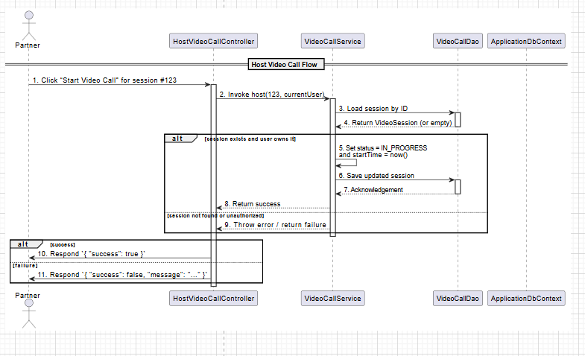

### d. Database Queries

-- 1. Load the target session

SELECT *

FROM VideoSessions

WHERE session_id = :sessionId;

-- 2. Mark it in-progress

UPDATE VideoSessions

SET status = 'IN_PROGRESS',

start_time = CURRENT_TIMESTAMP

WHERE session_id = :sessionId;

## 

## 30. View Course List

**Use Case:** UC-24: View Course List

### a. Class Diagram

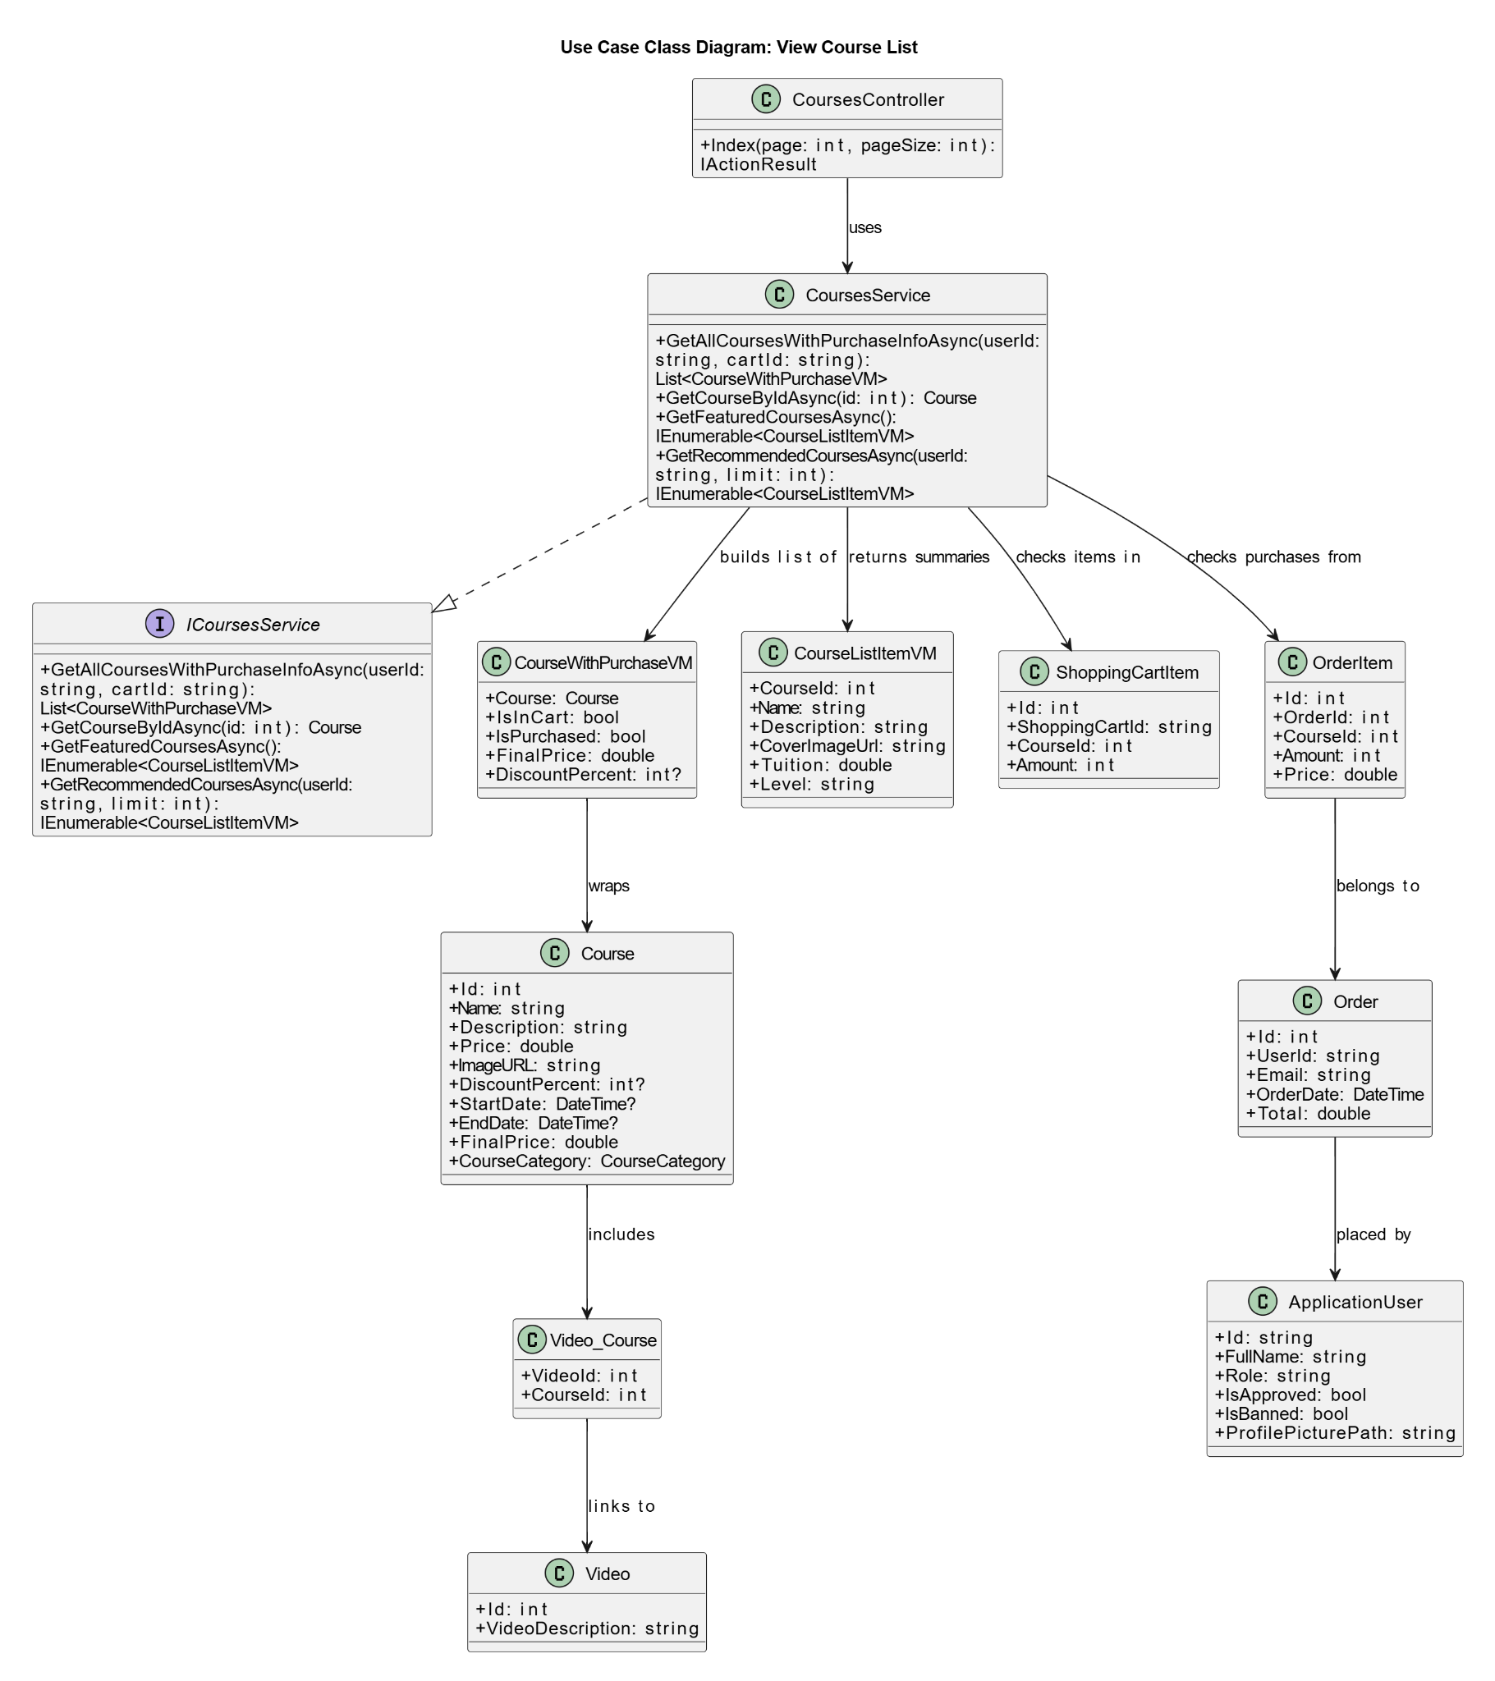

### b. Class Specifications

#### CoursesController

| **No** | **Method** | **Description** |
| --- | --- | --- |
| 01 | IActionResult Index(int page, int pageSize) | Handles GET request to show paginated course list. Calls CoursesService, returns View. |

#### CourseService

| **No** | **Method** | **Description** |
| --- | --- | --- |
| 01 | Task<List<CourseWithPurchaseVM>> GetAllCoursesWithPurchaseInfoAsync(string userId, string cartId) | Retrieves full course list and annotates each with cart/purchase status and final price. |
| 02 | Task<Course> GetCourseByIdAsync(int id) | Queries a course by ID including its related videos. |
| 03 | Task<IEnumerable<CourseListItemVM>> GetFeaturedCoursesAsync() | Gets 3 newest courses with price for home page. |
| 04 | Task<IEnumerable<CourseListItemVM>> GetRecommendedCoursesAsync(string userId, int limit) | Gets recommended courses for a user who hasn’t purchased them, based on most recent creation date. |

#### ICoursesService

| **No** | **Method** | **Description** |
| --- | --- | --- |
| 01 | Task<List<CourseWithPurchaseVM>> GetAllCoursesWithPurchaseInfoAsync(string userId, string cartId) | Interface definition for retrieving all courses with cart/purchase info. |
| 02 | Task<Course> GetCourseByIdAsync(int id) | Interface definition to retrieve a course by ID. |
| 03 | Task<IEnumerable<CourseListItemVM>> GetFeaturedCoursesAsync() | Interface definition to retrieve featured courses. |
| 04 | Task<IEnumerable<CourseListItemVM>> GetRecommendedCoursesAsync(string userId, int limit) | Interface definition to retrieve recommended courses. |

### c. Sequence Diagram

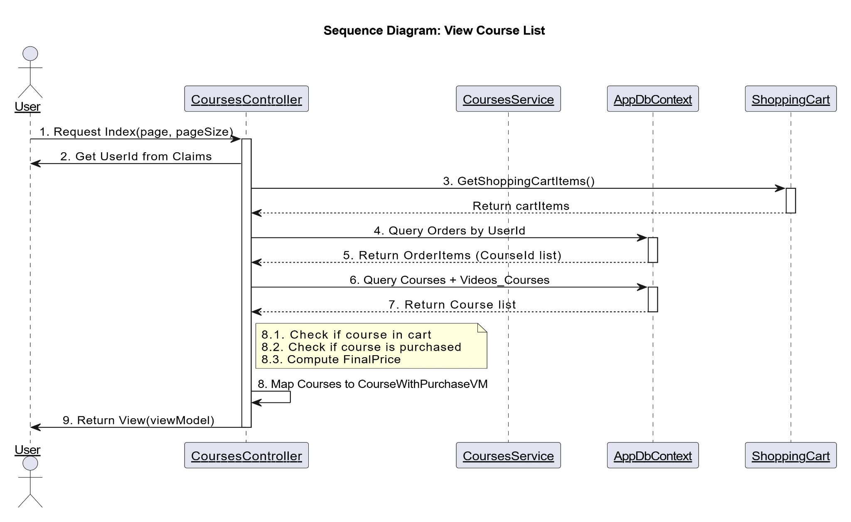

### d. Database Queries

SELECT

c.Id,

c.Name,

c.Description,

c.Price,

c.ImageURL,

c.DiscountPercent,

c.StartDate,

c.EndDate,

c.CourseCategoryId,

CASE

WHEN sc.CourseId IS NOT NULL THEN 1 ELSE 0

END AS IsInCart,

CASE

WHEN oi.CourseId IS NOT NULL THEN 1 ELSE 0

END AS IsPurchased,

CASE

WHEN c.DiscountPercent IS NOT NULL THEN

c.Price * (100 - c.DiscountPercent) / 100

ELSE c.Price

END AS FinalPrice

FROM Courses c

LEFT JOIN (

SELECT DISTINCT CourseId

FROM ShoppingCartItems

WHERE ShoppingCartId = @cartId

) sc ON c.Id = sc.CourseId

LEFT JOIN (

SELECT DISTINCT oi.CourseId

FROM Orders o

JOIN OrderItems oi ON o.Id = oi.OrderId

WHERE o.UserId = @userId) oi  
 ON c.Id = oi.CourseId

## 

## 31. Search a Course

**Use Case:** UC-25: Search a Course

### a. Class Diagram

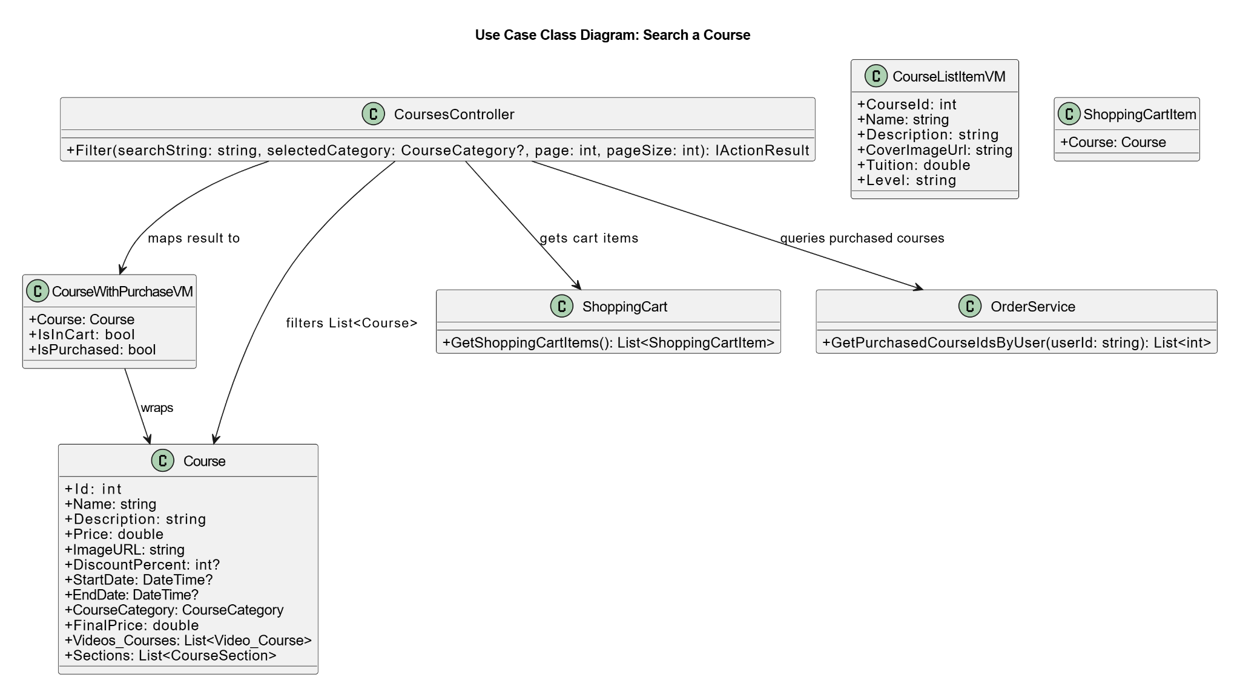

### b. Class Specifications

#### CourseController

| **No** | **Method** | **Description** |
| --- | --- | --- |
| 01 | Filter(string searchString, CourseCategory? selectedCategory, int page = 1, int pageSize = 6) | Handles course search and filtering by keyword and category, performs pagination, maps results to view model, and returns the View. |

#### 

#### CourseService

| **No** | **Method** | **Description** |
| --- | --- | --- |
| 01 | GetAllAsync() | Retrieves all courses from the database to be filtered in the controller. |

#### ShoppingCart

| **No** | **Method** | **Description** |
| --- | --- | --- |
| 01 | GetShoppingCartItems() | Returns a list of current items in the user's shopping cart, including their associated courses. |

### 

#### OrderService

| **No** | **Method** | **Description** |
| --- | --- | --- |
| 01 | GetPurchasedCourseIdsByUser(string userId) | Returns a list of CourseId values that the user has previously purchased, based on their user ID. |

### c. Sequence Diagram

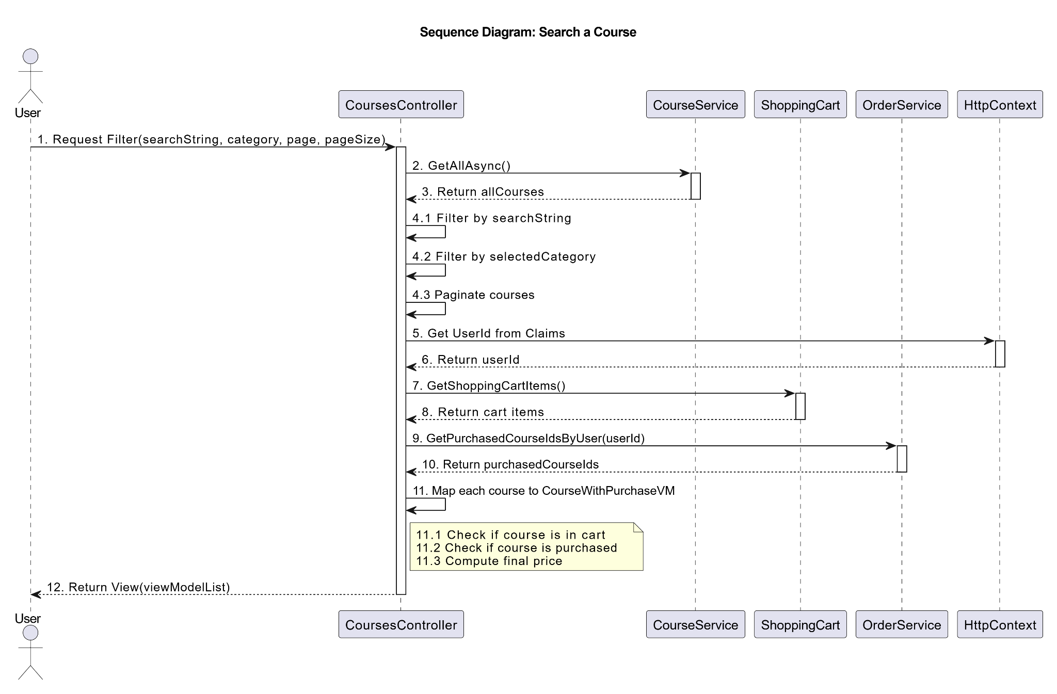

### d. Database Queries

DECLARE @SearchString NVARCHAR(100) = N'japan';

DECLARE @SelectedCategory INT = 1; -- Enum: CourseCategory

DECLARE @Page INT = 2;

DECLARE @PageSize INT = 6;

DECLARE @UserId NVARCHAR(450) = 'user-guid-here'; -- From Claims

DECLARE @Offset INT = (@Page - 1) * @PageSize;

## 

## 32. View Course Details

**Use Case:** UC-26: View Course Details

### a. Class Diagram

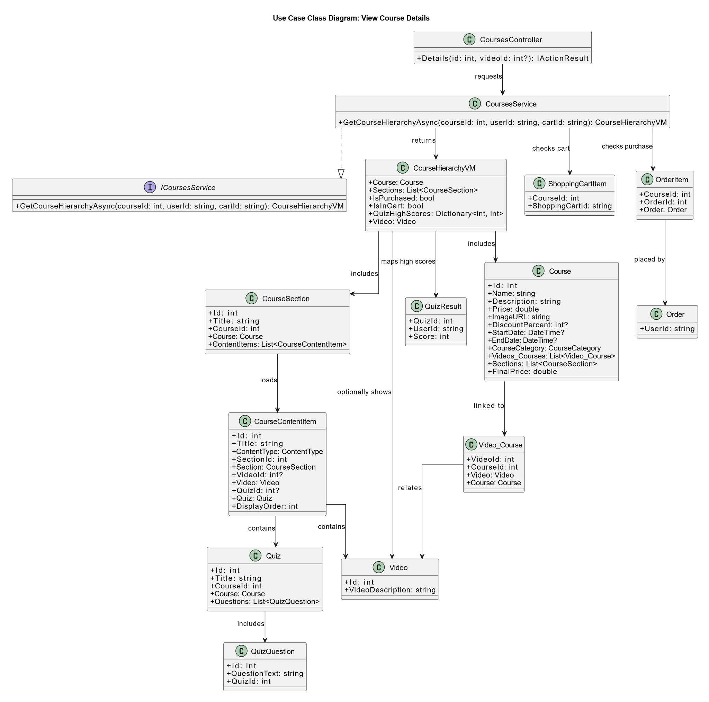

### 

### b. Class Specifications

#### CourseController

| **No** | **Method** | **Description** |
| --- | --- | --- |
| 01 | Details(int id, int? videoId = null) | Handles HTTP GET request to view course details. Retrieves course hierarchy using service, then returns to View or NotFound. |

#### CourseService

| **No** | **Method** | **Description** |
| --- | --- | --- |
| 01 | GetCourseHierarchyAsync(int courseId, string userId, string cartId) | Retrieves a CourseHierarchyVM by loading course details with sections, content items, quiz scores, and cart/purchase status. |

#### ICoursesService

| **No** | **Method** | **Description** |
| --- | --- | --- |
| 01 | GetCourseHierarchyAsync(int courseId, string userId, string cartId) | Interface method that defines contract for retrieving a complete course hierarchy for a user. |

### 

### c. Sequence Diagram

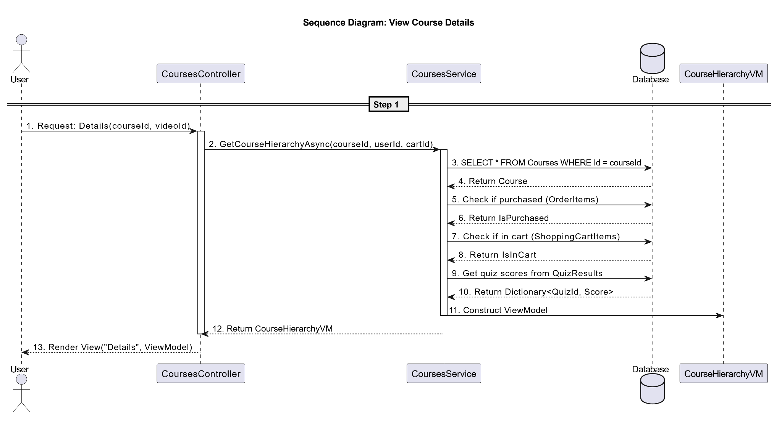

### d. Database Queries

SELECT

c.Id,

c.Name,

c.Description,

c.Price,

c.ImageURL,

c.DiscountPercent,

c.StartDate,

c.EndDate,

c.CourseCategory

FROM Courses c

WHERE c.Id = @CourseId;

SELECT COUNT(1)

FROM OrderItems oi

JOIN Orders o ON oi.OrderId = o.Id

WHERE oi.CourseId = @CourseId AND o.UserId = @UserId;

SELECT COUNT(1)

FROM ShoppingCartItems

WHERE CourseId = @CourseId AND ShoppingCartId = @CartId;

SELECT

r.QuizId,

MAX(r.Score) AS MaxScore

FROM QuizResults r

WHERE r.UserId = @UserId

AND r.QuizId IN (

SELECT ci.QuizId

FROM CourseSections s

JOIN CourseContentItems ci ON ci.SectionId = s.Id

WHERE s.CourseId = @CourseId AND ci.QuizId IS NOT NULL

)

GROUP BY r.QuizId;

## 33. Buy Course

**Use Case:** UC-27: Buy Course

### a. Class Diagram

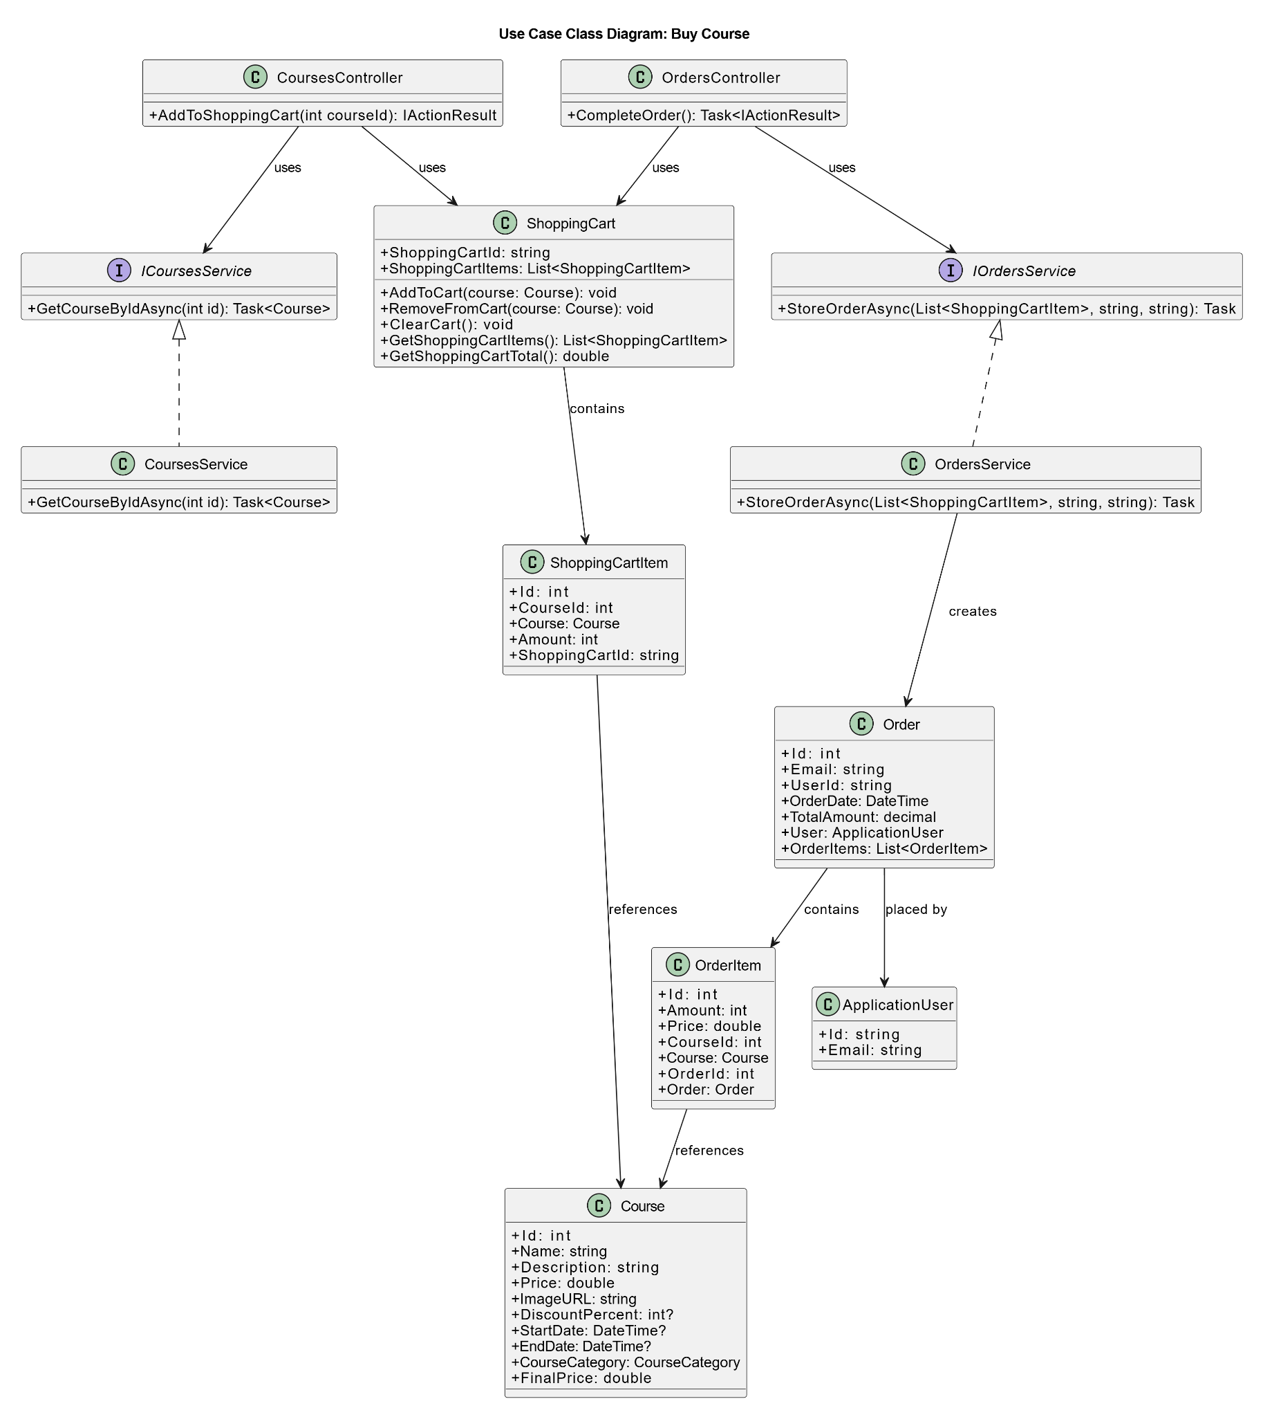

### 

### b. Class Specifications

#### ShoppingCartController

| **No** | **Method** | **Description** |
| --- | --- | --- |
| 01 | BuyCourse() | Handles user action to purchase the items in the shopping cart. Delegates to the OrdersService and clears the cart. |

#### ShoppingCart

| **No** | **Method** | **Description** |
| --- | --- | --- |
| 01 | GetShoppingCartItems() | Creates order record via OrderDao, returns payment URL (e.g. PayPal) for redirection. |
| 02 | ClearCart() | Clears all items from the shopping cart after purchase. |
| 03 | GetShoppingCartTotal() | Calculates the total cost of items in the shopping cart. |

#### OrdersService

| **No** | **Method** | **Description** |
| --- | --- | --- |
| 01 | StoreOrderAsync(List<ShoppingCartItem> items, string userId, string email) | Creates and saves a new order and its order items based on the shopping cart contents. |
| 02 | GetOrdersByUserId(string userId) | Retrieves all orders placed by the given user. |

### 

### c. Sequence Diagram

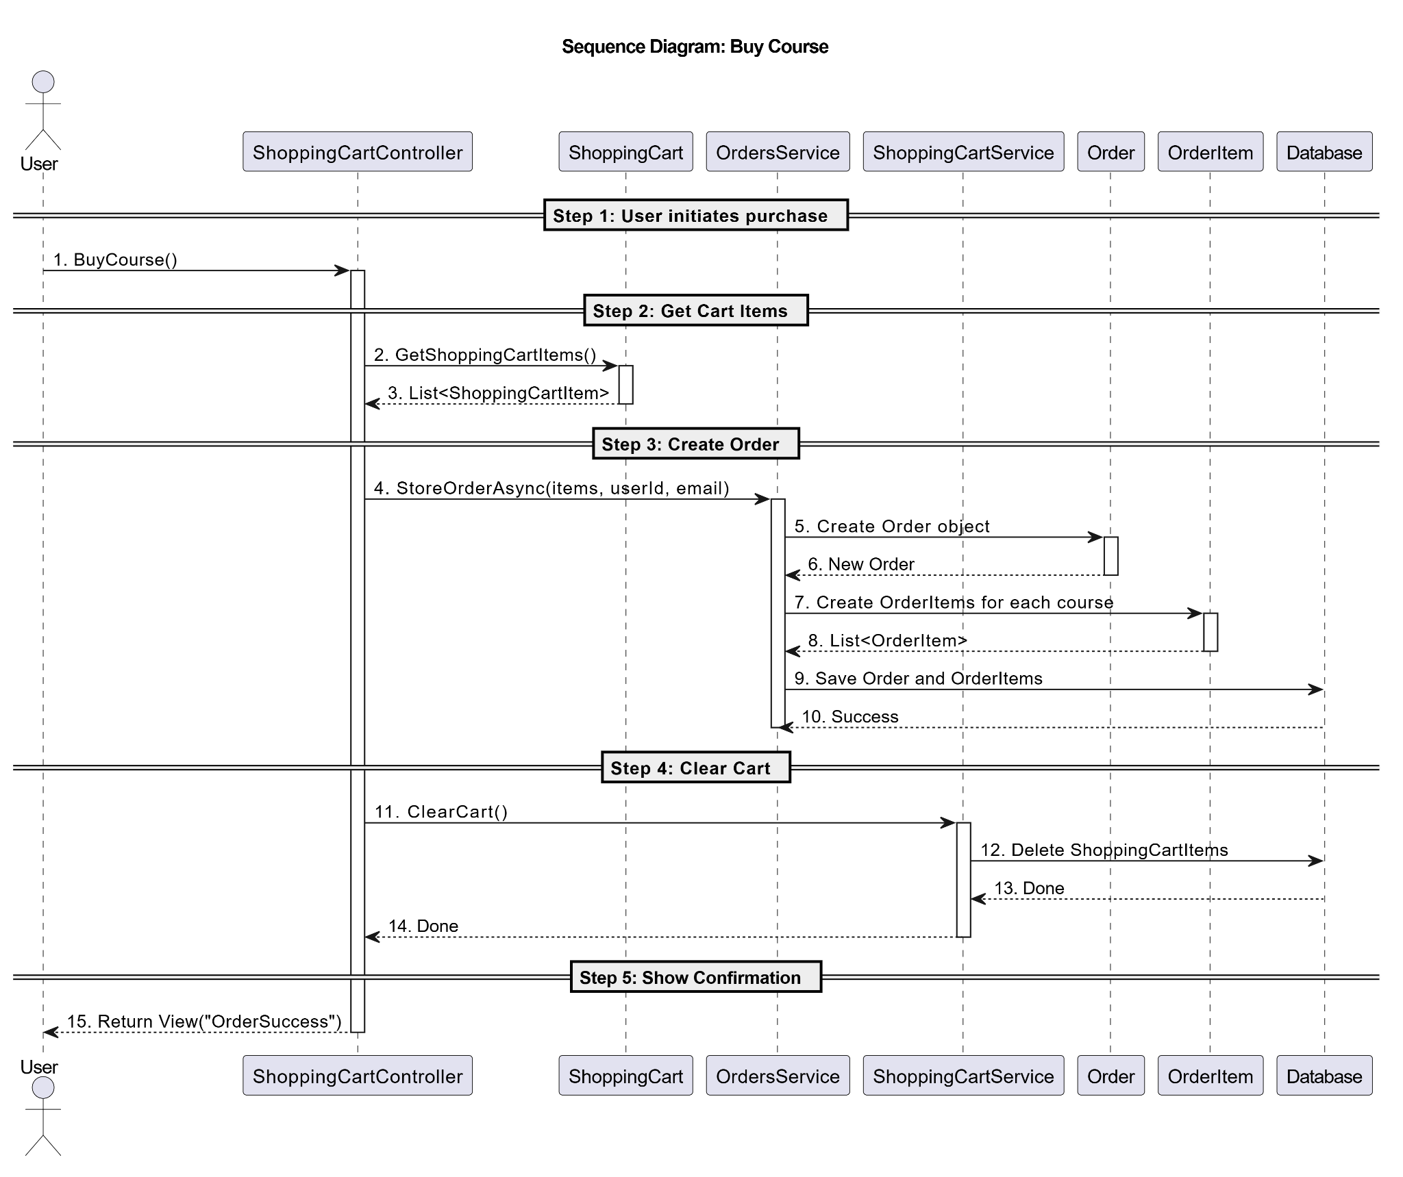

### d. Database Queries

SELECT sci.Id, sci.CourseId, c.Name, c.Price, c.DiscountPercent,

ISNULL((c.Price * (100 - c.DiscountPercent)) / 100.0, c.Price) AS FinalPrice

FROM ShoppingCartItems sci

JOIN Courses c ON sci.CourseId = c.Id

WHERE sci.ShoppingCartId = @CartId;

SELECT SUM(ISNULL((c.Price * (100 - c.DiscountPercent)) / 100.0, c.Price)) AS TotalAmount

FROM ShoppingCartItems sci

JOIN Courses c ON sci.CourseId = c.Id

WHERE sci.ShoppingCartId = @CartId;

INSERT INTO Orders (Email, UserId, OrderDate, TotalAmount)

VALUES (@Email, @UserId, GETDATE(), @TotalAmount);

SELECT SCOPE_IDENTITY() AS NewOrderId;

INSERT INTO OrderItems (Amount, Price, CourseId, OrderId)

SELECT 1, ISNULL((c.Price * (100 - c.DiscountPercent)) / 100.0, c.Price), c.Id, @OrderId

FROM ShoppingCartItems sci

JOIN Courses c ON sci.CourseId = c.Id

WHERE sci.ShoppingCartId = @CartId;

SELECT o.Id, o.OrderDate, o.TotalAmount, oi.CourseId, c.Name, oi.Price

FROM Orders o

JOIN OrderItems oi ON o.Id = oi.OrderId

JOIN Courses c ON oi.CourseId = c.Id

WHERE o.UserId = @UserId

ORDER BY o.OrderDate DESC;

SELECT Email FROM AspNetUsers

WHERE Id = @UserId;

## 

## 34. Confirm Course Payment

**Use Case:** UC-28: Confirm Course Payment

### a. Class Diagram

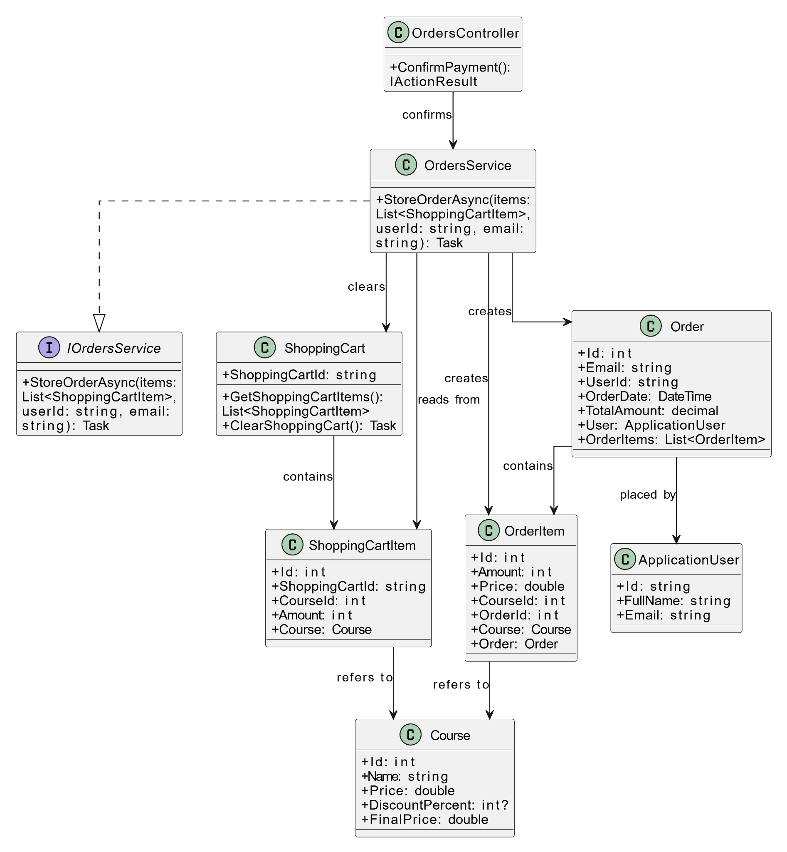

### b. Class Specifications

CoursesController

| **No** | **Method** | **Description** |
| --- | --- | --- |
| 1 | ConfirmPayment(int orderId) : Task<IActionResult> | Handles the course payment confirmation logic after the order has been placed. |

ShoppingCart

| **No** | **Method** | **Description** |
| --- | --- | --- |
| 1 | GetShoppingCartItems(): List<ShoppingCartItem> | Retrieves the list of items currently in the shopping cart.. |
| 2 | ClearShoppingCartAsync(): Task | Clears all items in the shopping cart asynchronously. |

IOrdersService

| **No** | **Method** | **Description** |
| --- | --- | --- |
| 1 | StoreOrderAsync(items: List<ShoppingCartItem>, userId: string, email: string): Task | Persists a new order and its items to the database using the provided user and cart data. |

### 

OrdersService

| **No** | **Method** | **Description** |
| --- | --- | --- |
| 1 | StoreOrderAsync(List<ShoppingCartItem> items, string userId, string email) : Task | Stores a new order into the system, including all related order items. |

### 

OrdersRepository

| **No** | **Method** | **Description** |
| --- | --- | --- |
| 1 | CreateOrder(List<ShoppingCartItem> items, string userId, string email) : Task<Order> | Creates a new order and persists it to the database. |

### c. Sequence Diagram

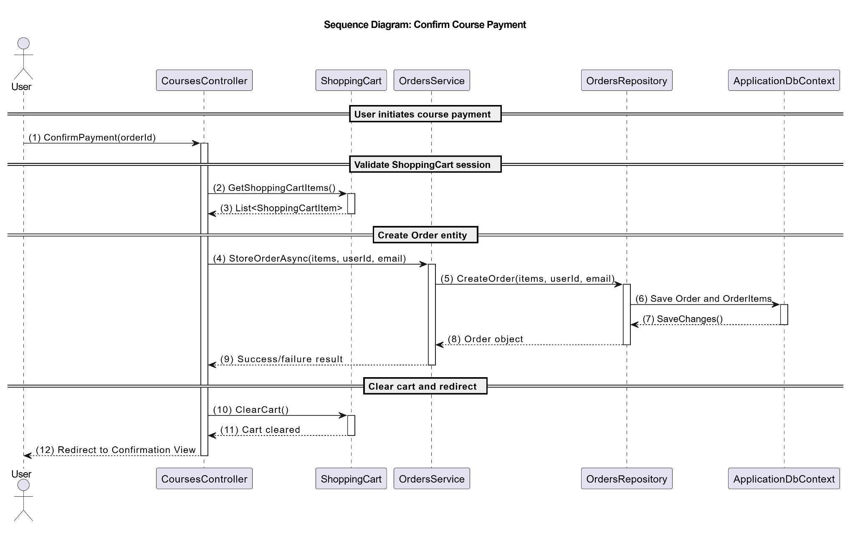

### d. Database Queries

SELECT sci.Id, sci.CourseId, c.Name, c.Price

FROM ShoppingCartItems sci

JOIN Courses c ON sci.CourseId = c.Id

WHERE sci.ShoppingCartId = @CartId;

INSERT INTO Orders (Email, UserId, OrderDate, TotalAmount)

VALUES (@Email, @UserId, GETDATE(), @TotalAmount);

DECLARE @OrderId INT = SCOPE_IDENTITY();

INSERT INTO OrderItems (Amount, Price, CourseId, OrderId)

SELECT

1 AS Amount,

c.Price,

c.Id,

@OrderId

FROM ShoppingCartItems sci

JOIN Courses c ON sci.CourseId = c.Id

WHERE sci.ShoppingCartId = @CartId;

DELETE FROM ShoppingCartItems

WHERE ShoppingCartId = @CartId;

SELECT o.Id AS OrderId, o.OrderDate, o.TotalAmount, oi.CourseId, c.Name, oi.Price

FROM Orders o

JOIN OrderItems oi ON o.Id = oi.OrderId

JOIN Courses c ON c.Id = oi.CourseId

WHERE o.Id = @OrderId;

## 

## 35. View My Courses

**Use Case:** UC-29: View My Courses

### a. Class Diagram

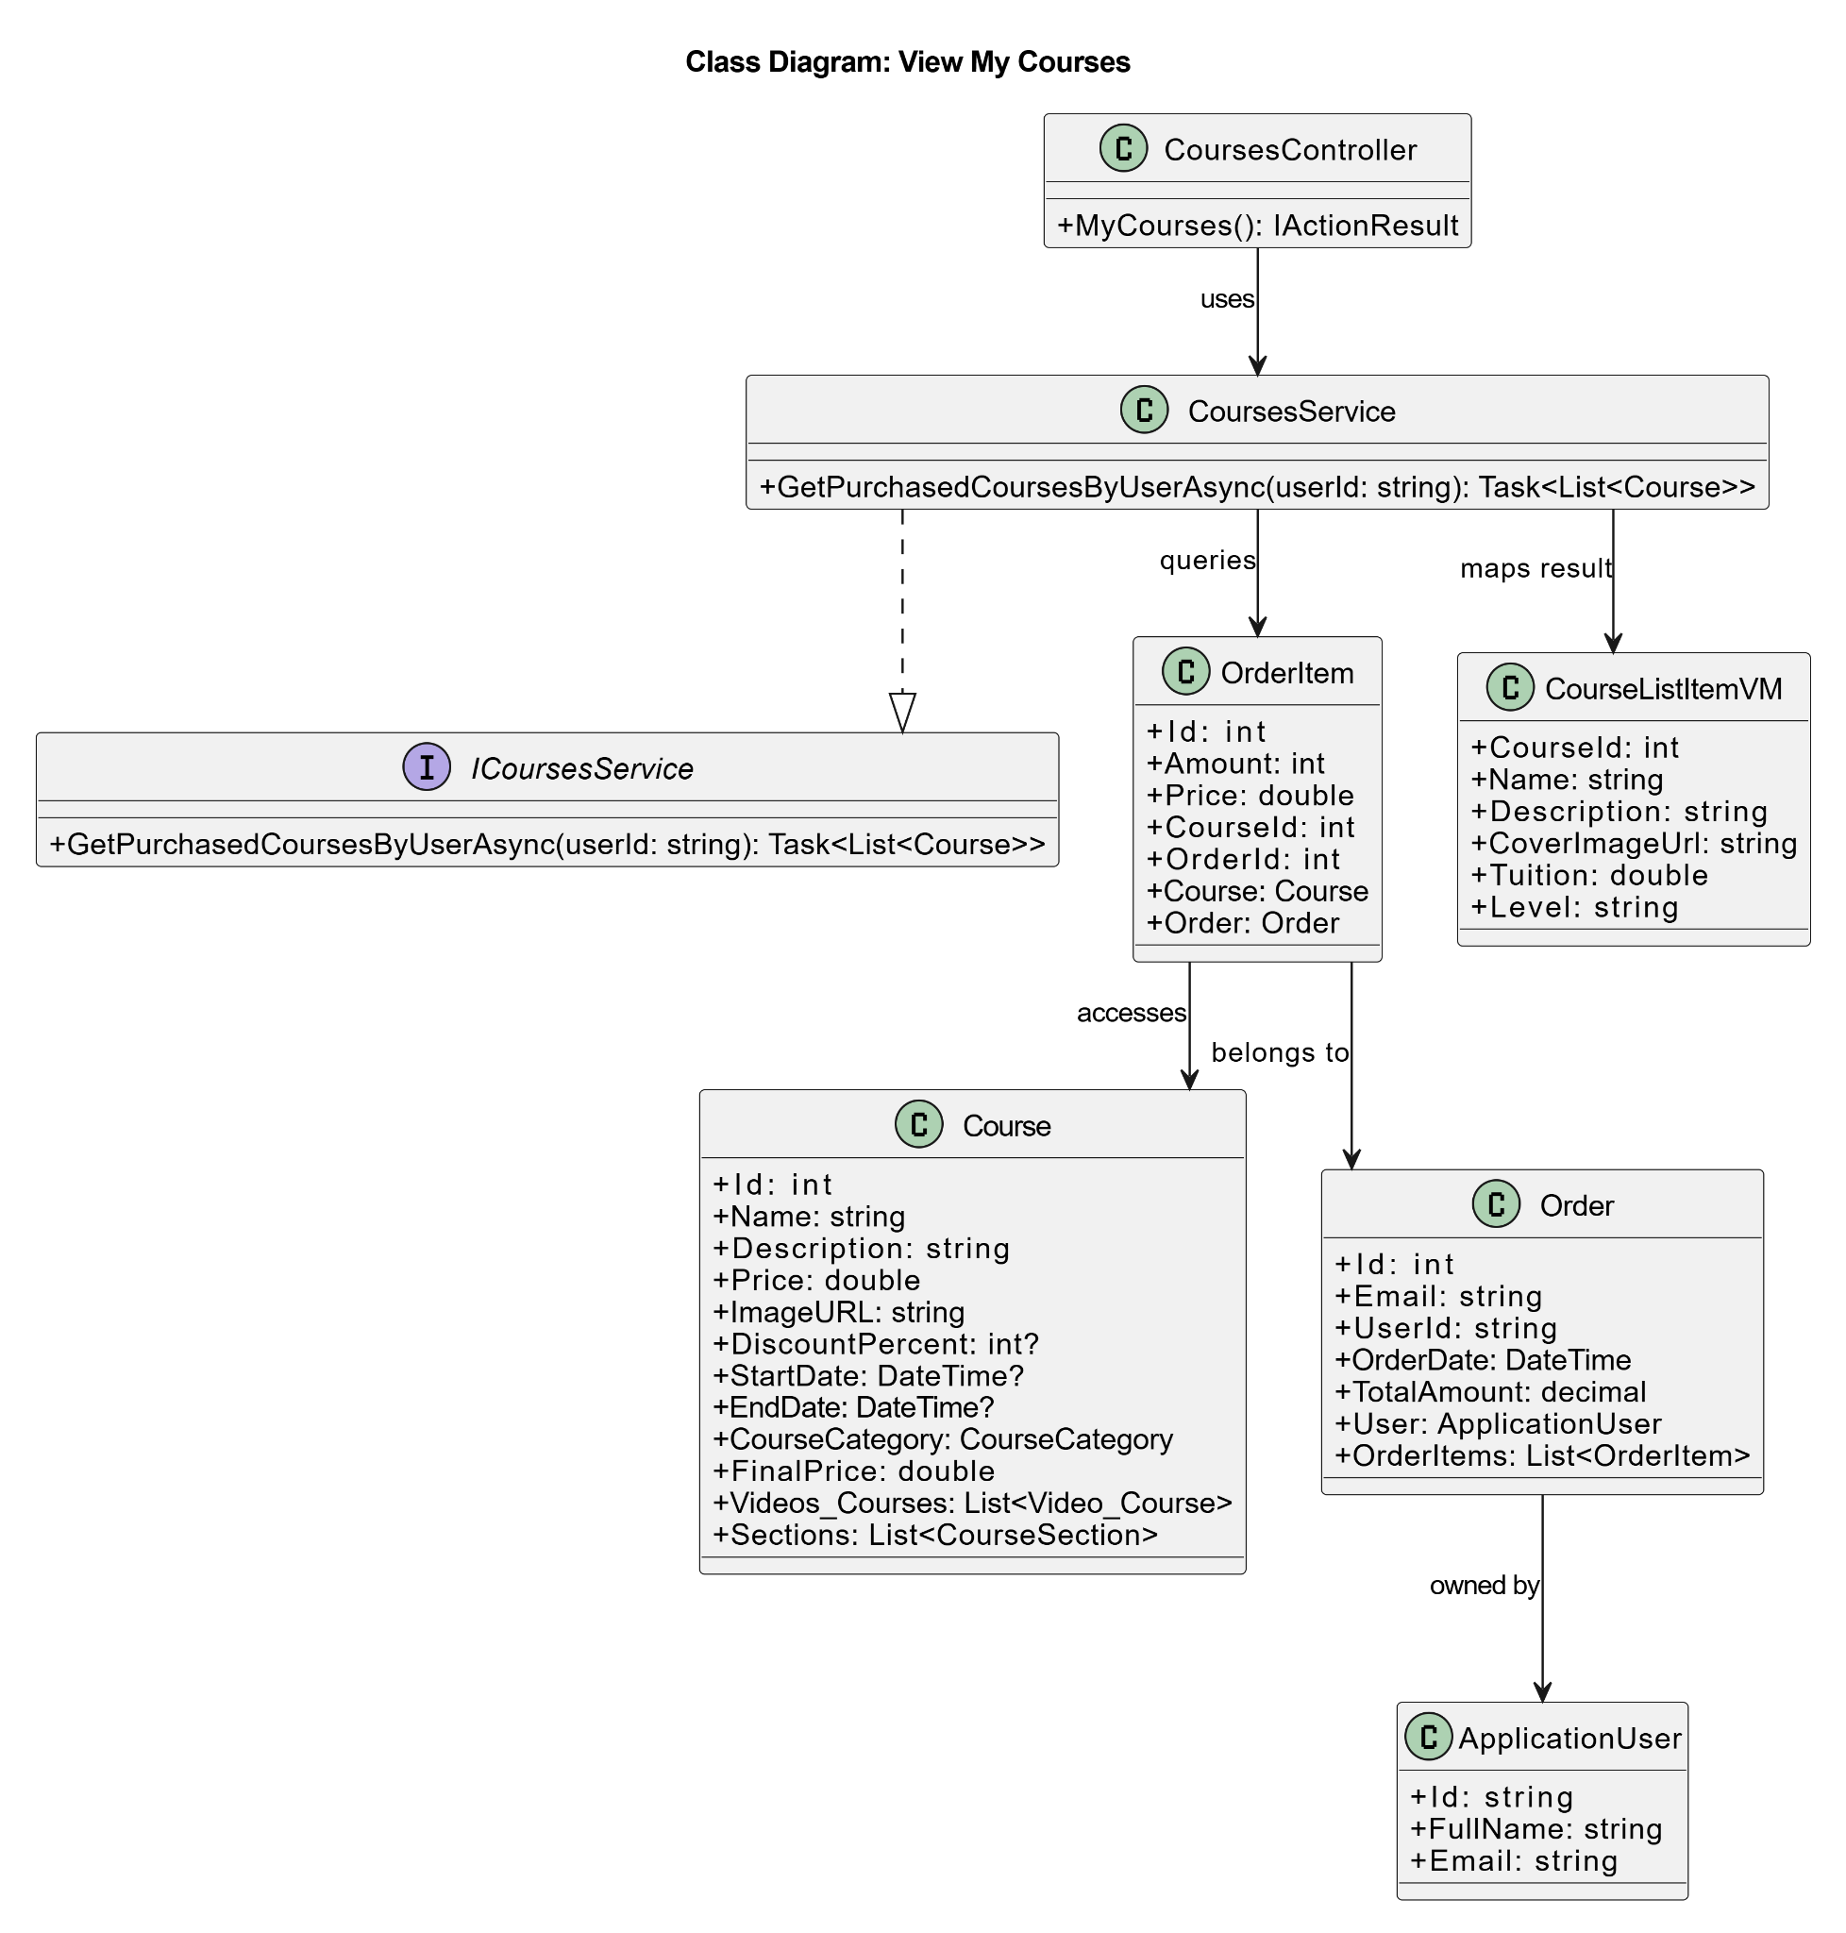

### 

### b. Class Specifications

#### CoursesController

| **No** | **Method** | **Description** |
| --- | --- | --- |
| 1 | Task<IActionResult> ConfirmPayment(string orderId) | Handles the payment confirmation request. Retrieves items from ShoppingCart, calls OrdersService.StoreOrderAsync(), clears cart, and redirects to confirmation view. |

#### ShoppingCart

| **No** | **Method** | **Description** |
| --- | --- | --- |
| 1 | List<ShoppingCartItem> GetShoppingCartItems() | Retrieves all items currently in the user's shopping cart. |
| 2 | void ClearCart() | Clears all items from the current shopping cart session. |

### c. Sequence Diagram

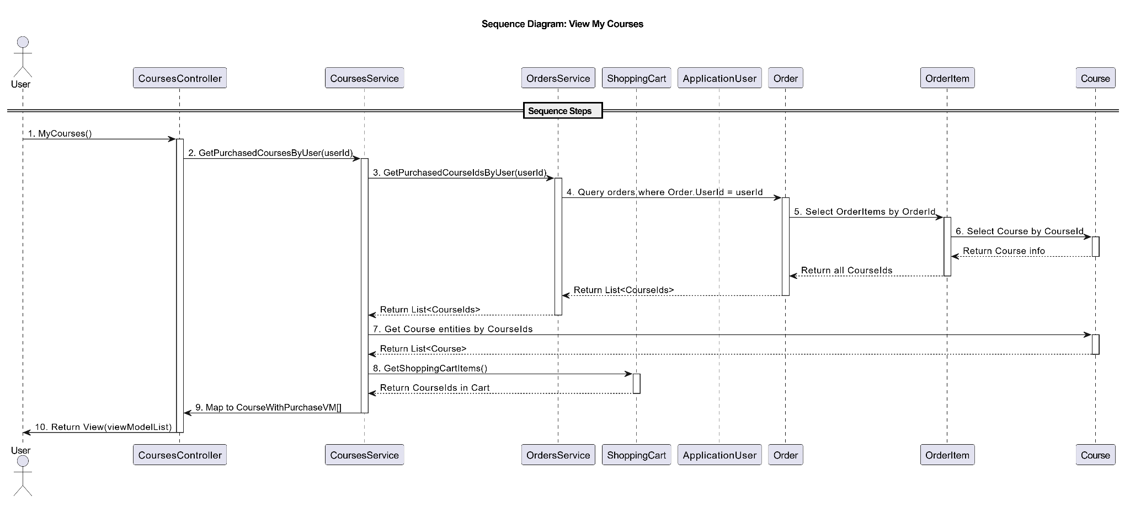

### d. Database Queries

INSERT INTO [Orders] (Email, UserId, OrderDate, TotalAmount)

VALUES (@Email, @UserId, GETDATE(), @TotalAmount);

DECLARE @OrderId INT = SCOPE_IDENTITY();

INSERT INTO [OrderItems] (Amount, Price, CourseId, OrderId)

SELECT

s.Amount,

c.Price * (1 - ISNULL(c.DiscountPercent, 0) / 100.0),

s.CourseId,

@OrderId

FROM [ShoppingCartItems] s

JOIN [Courses] c ON s.CourseId = c.Id

WHERE s.ShoppingCartId = @CartId;

DELETE FROM [ShoppingCartItems]

WHERE ShoppingCartId = @CartId;

SELECT o.Id AS OrderId, o.Email, o.OrderDate, o.TotalAmount,

oi.CourseId, c.Name AS CourseName, oi.Price, oi.Amount

FROM [Orders] o

JOIN [OrderItems] oi ON o.Id = oi.OrderId

JOIN [Courses] c ON oi.CourseId = c.Id

WHERE o.Id = @OrderId;

## 36. Watch Video Lessons

**Use Case:** UC-30: Watch Video Lessons

### a. Class Diagram

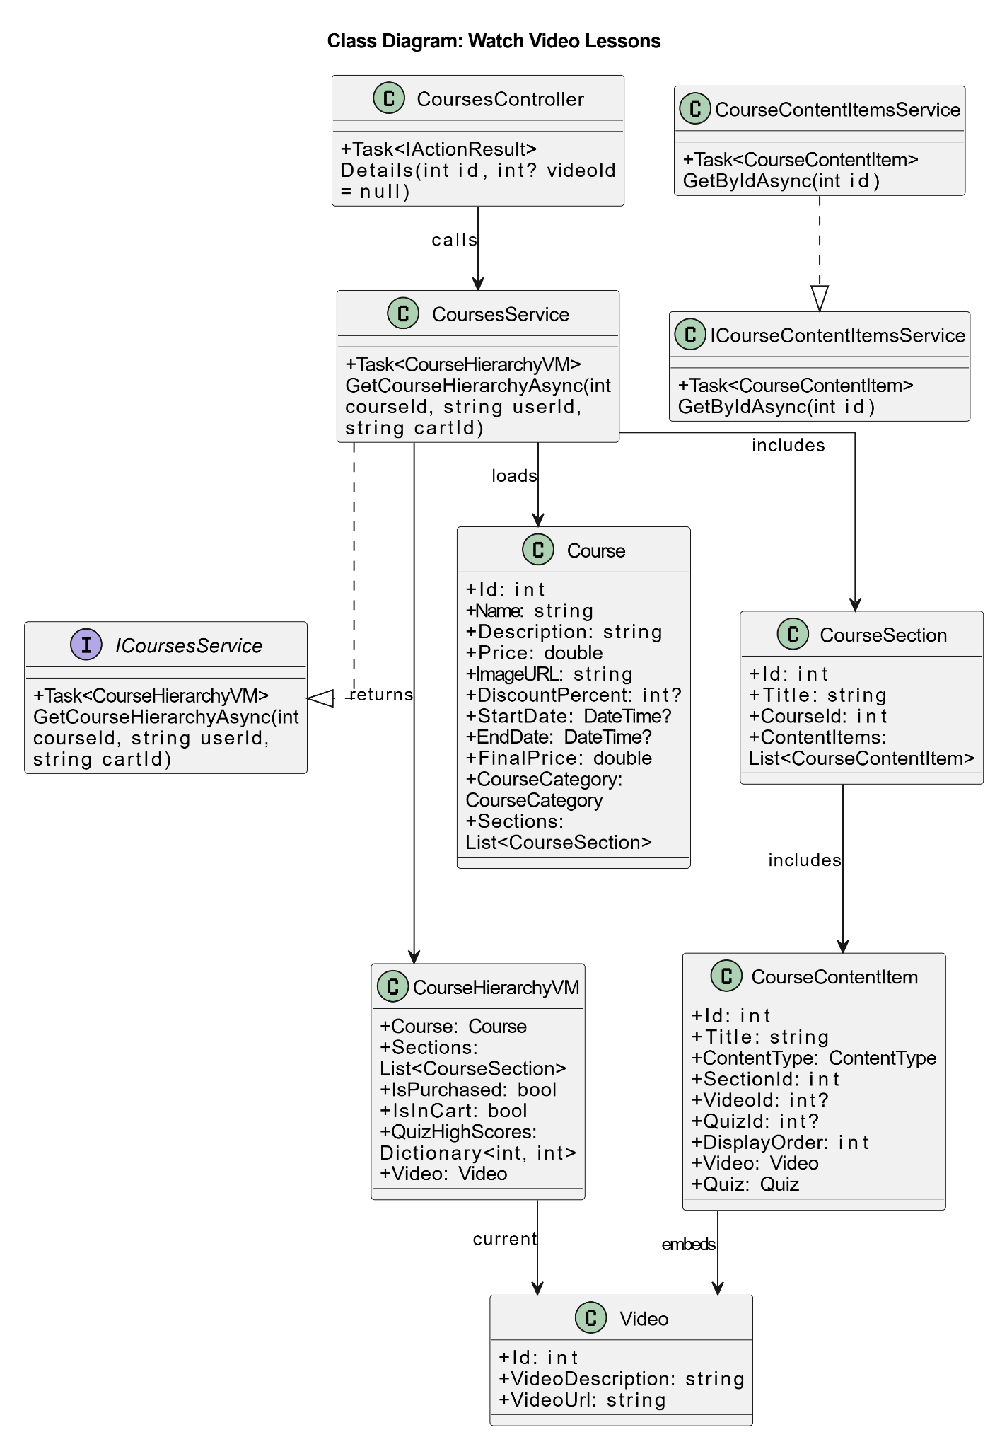

### 

### b. Class Specifications

#### CoursesController

| **No** | **Method** | **Description** |
| --- | --- | --- |
| 1 | Task<IActionResult> Details(int id, int? videoId) | Handles the course details request with an optional video ID and returns the view model for rendering the lesson video page. |

#### 

#### CoursesService

| **No** | **Method** | **Description** |
| --- | --- | --- |
| 1 | Task<CourseHierarchyVM> GetCourseHierarchyAsync(int courseId, string userId, string cartId) | Retrieves full course details including sections, content items, videos, quizzes, cart and purchase status, and user quiz scores. |

#### c. Sequence Diagram

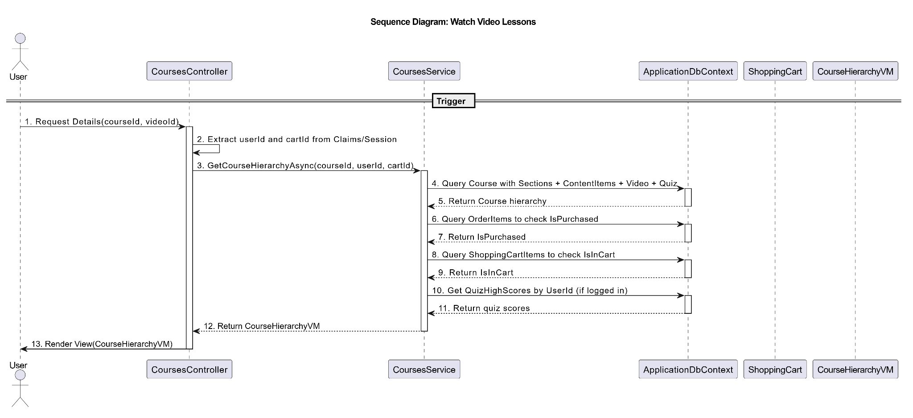

### 

### d. Database Queries

SELECT

c.Id AS CourseId, c.Name, c.Description, c.Price, c.ImageURL, c.CourseCategory,

cs.Id AS SectionId, cs.Title AS SectionTitle,

cci.Id AS ContentItemId, cci.Title AS ContentItemTitle,

cci.ContentType, cci.DisplayOrder,

v.Id AS VideoId, v.VideoDescription,

q.Id AS QuizId, q.Title AS QuizTitle

FROM Courses c

LEFT JOIN CourseSections cs ON cs.CourseId = c.Id

LEFT JOIN CourseContentItems cci ON cci.SectionId = cs.Id

LEFT JOIN Videos v ON v.Id = cci.VideoId

LEFT JOIN Quizzes q ON q.Id = cci.QuizId

WHERE c.Id = @CourseId

ORDER BY cs.Id, cci.DisplayOrder;

SELECT COUNT(*)

FROM OrderItems oi

JOIN Orders o ON o.Id = oi.OrderId

WHERE oi.CourseId = @CourseId AND o.UserId = @UserId;

SELECT COUNT(*)

FROM ShoppingCartItems

WHERE CourseId = @CourseId AND ShoppingCartId = @CartId;

SELECT DISTINCT ci.QuizId

FROM Courses c

JOIN CourseSections cs ON cs.CourseId = c.Id

JOIN CourseContentItems ci ON ci.SectionId = cs.Id

WHERE c.Id = @CourseId AND ci.QuizId IS NOT NULL;

SELECT

QuizId,

MAX(Score) AS MaxScore

FROM QuizResults

WHERE UserId = @UserId AND QuizId IN (

-- Optional: replace with list of QuizIds or subquery

SELECT DISTINCT ci.QuizId

FROM Courses c

JOIN CourseSections cs ON cs.CourseId = c.Id

JOIN CourseContentItems ci ON ci.SectionId = cs.Id

WHERE c.Id = @CourseId AND ci.QuizId IS NOT NULL

)

GROUP BY QuizId;

SELECT Id, VideoDescription

FROM Videos

WHERE Id = @VideoId;

## 

## 37. Rate Course

**Use Case:** UC-31: Rate Course

### a. Class Diagram

### b. Class Specifications

#### RateCourseController

| **No** | **Method** | **Description** |
| --- | --- | --- |
| 01 | void doPost(HttpServletRequest req, HttpServletResponse res) | Reads courseId, stars, comment; calls CourseService.rate(user, form), redirects back to detail. |

#### CourseService

| **No** | **Method** | **Description** |
| --- | --- | --- |
| 01 | void rate(long learnerId, long courseId, int stars, String rev) | Validates completion via DAO, upserts via RatingDao.upsert(), updates average via RatingDao.recalcAvg(). |

#### RatingDao

| **No** | **Method** | **Description** |
| --- | --- | --- |
| 01 | void upsert(long learnerId, long courseId, int stars, String rev) | MERGE INTO CourseRatings ... WHEN MATCHED UPDATE ... WHEN NOT MATCHED INSERT ... |
| 02 | void recalcAvg(long courseId) | UPDATE Courses SET evaluation_point = (SELECT AVG(stars) FROM CourseRatings WHERE course_id=?) WHERE course_id=? |

### c. Sequence Diagram

### d. Database Queries

MERGE INTO CourseRatings AS cr  
 USING (VALUES(?, ?, ?, ?, CURRENT_TIMESTAMP)) AS src(learner_id,course_id,stars,review,created_at)  
 ON cr.learner_id=src.learner_id AND cr.course_id=src.course_id  
 WHEN MATCHED THEN  
 UPDATE SET stars=src.stars, review=src.review, updated_at=CURRENT_TIMESTAMP  
 WHEN NOT MATCHED THEN  
 INSERT (learner_id, course_id, stars, review, created_at)  
 VALUES(src.learner_id, src.course_id, src.stars, src.review, src.created_at);

UPDATE Courses  
 SET evaluation_point = (SELECT AVG(stars) FROM CourseRatings WHERE course_id = ?)  
 WHERE course_id = ?;

## 

## 38. View Courses (Admin)

**Use Case:** UC-32: View Courses

### a. Class Diagram

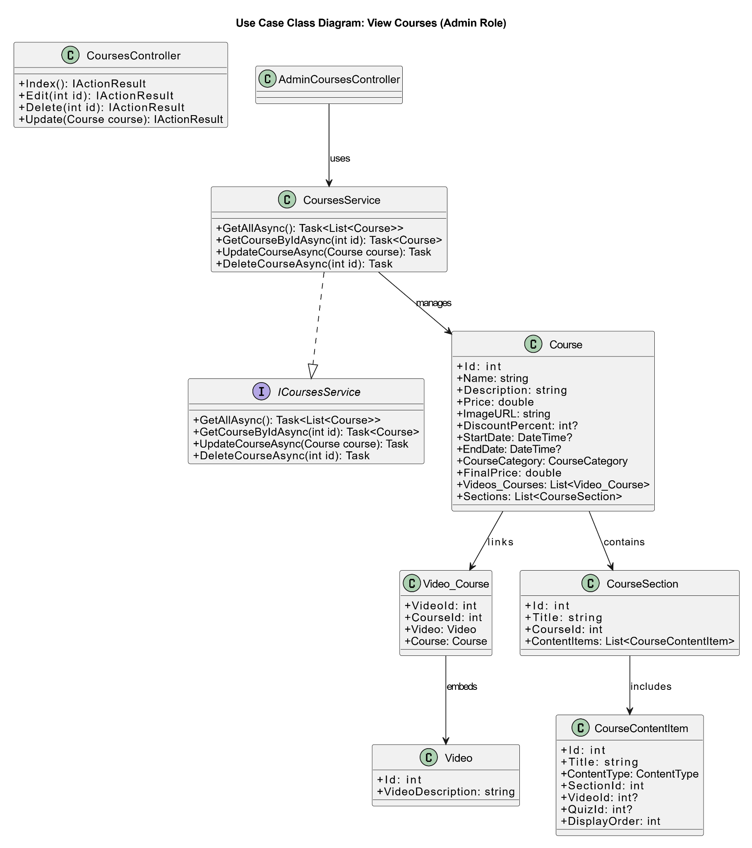

### 

### b. Class Specifications

#### CourseController

| **No** | **Method** | **Description** |
| --- | --- | --- |
| 01 | Details(int id, int? videoId = null) | Handles HTTP GET request to view course details. Retrieves course hierarchy using service, then returns to View or NotFound. |

#### CoursesService

| **No** | **Method** | **Description** |
| --- | --- | --- |
| 01 | GetAllCoursesAsync(): Task<List<Course>> | Retrieves all courses from the database including their related data (e.g., sections, content items, videos). |
| 02 | GetCourseHierarchyAsync(int courseId, string userId, string cartId) | Retrieves a CourseHierarchyVM by loading course details with sections, content items, quiz scores, and cart/purchase status. |

#### AppDbContext

| **No** | **Method** | **Description** |
| --- | --- | --- |
| 01 | Courses | Represents the Courses table in the database, used to query all course data. |
| 02 | Orders | Saves any changes made in the context to the database asynchronously. (Not used in this read-only use case, but part of infrastructure.) |

### 

### c. Sequence Diagram

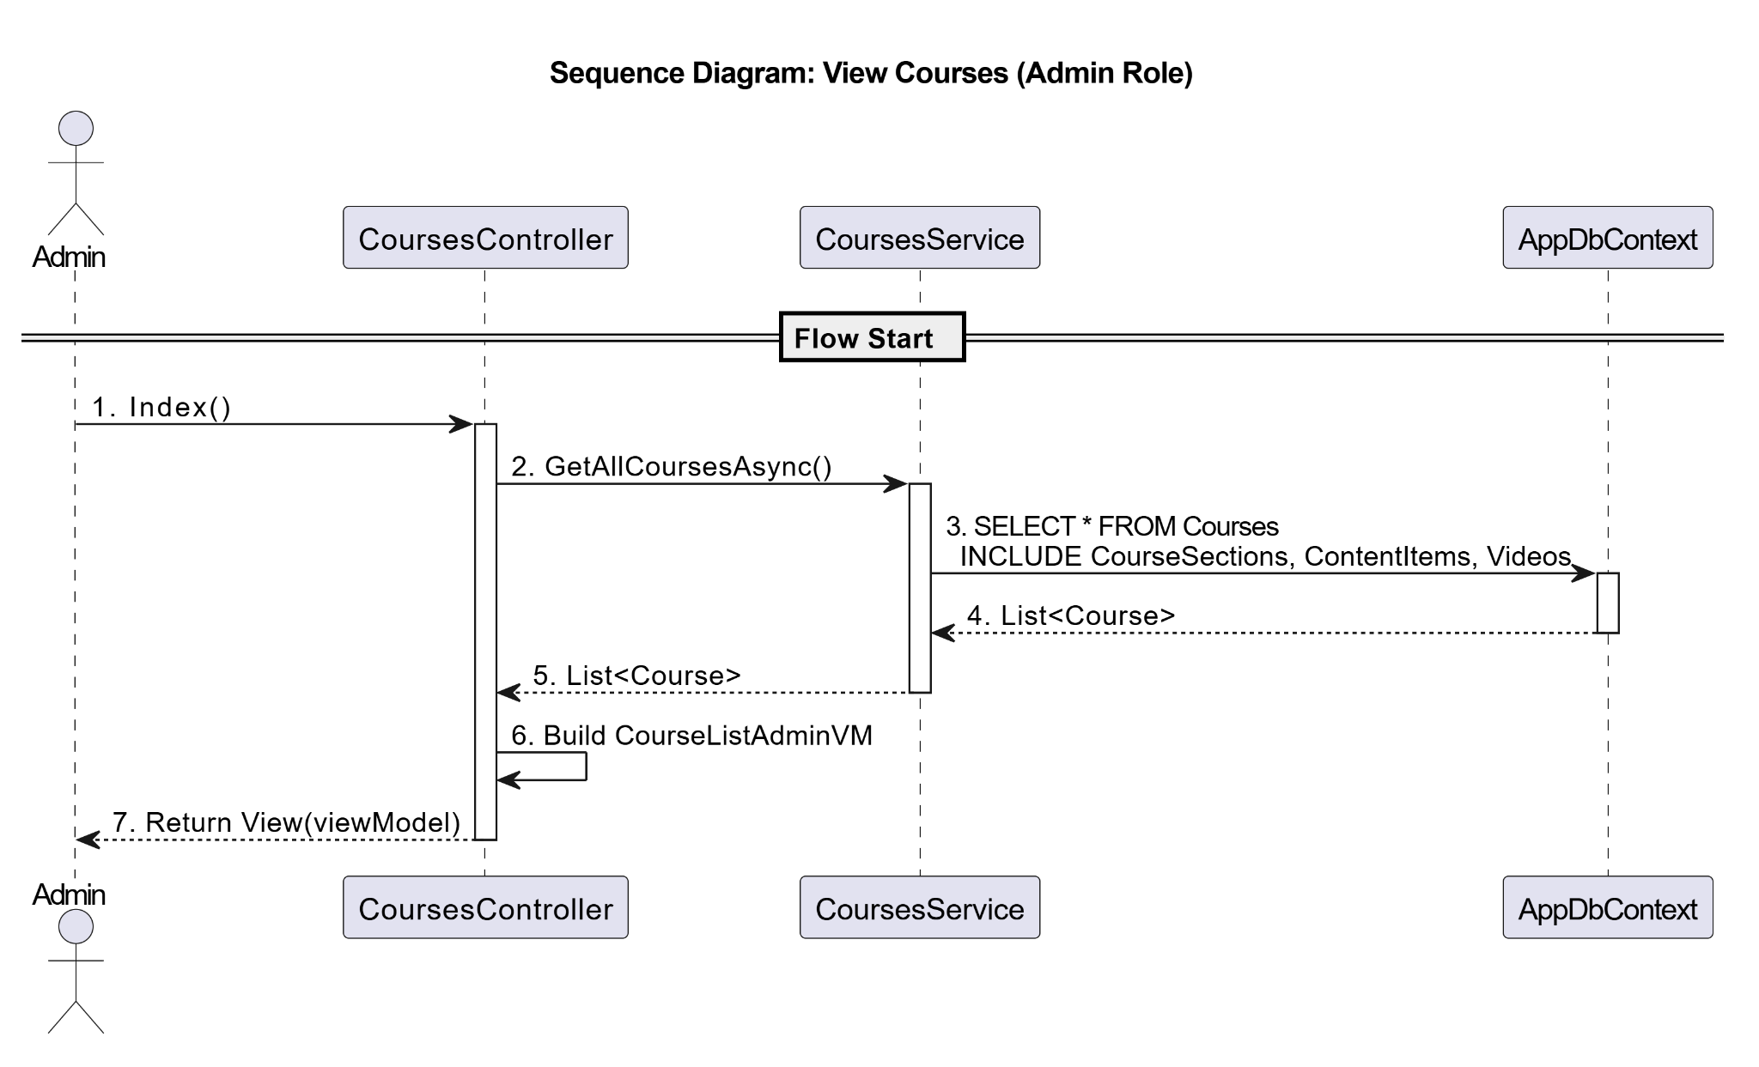

### d. Database Queries

SELECT

c.Id,

c.Name,

c.Description,

c.Price,

c.ImageURL,

c.DiscountPercent,

c.StartDate,

c.EndDate,

c.CourseCategory

FROM Courses c

ORDER BY c.StartDate DESC;

SELECT

c.Id AS CourseId,

c.Name,

COUNT(DISTINCT s.Id) AS TotalSections,

COUNT(ci.Id) AS TotalContentItems

FROM Courses c

LEFT JOIN CourseSections s ON s.CourseId = c.Id

LEFT JOIN CourseContentItems ci ON ci.SectionId = s.Id

GROUP BY c.Id, c.Name

ORDER BY c.Name;

SELECT

c.Id AS CourseId,

c.Name AS CourseName,

s.Id AS SectionId,

s.Title AS SectionTitle,

ci.Id AS ContentItemId,

ci.Title AS ContentItemTitle,

ci.ContentType,

ci.DisplayOrder

FROM Courses c

LEFT JOIN CourseSections s ON s.CourseId = c.Id

LEFT JOIN CourseContentItems ci ON ci.SectionId = s.Id

ORDER BY c.Name, s.Id, ci.DisplayOrder;

SELECT

c.Id AS CourseId,

c.Name AS CourseName,

v.Id AS VideoId,

v.VideoDescription

FROM Courses c

INNER JOIN Video_Course vc ON vc.CourseId = c.Id

INNER JOIN Videos v ON v.Id = vc.VideoId

ORDER BY c.Name;

## 

## 39. Create a Course

**Use Case:** UC-32a: Create a Course

### a. Class Diagram

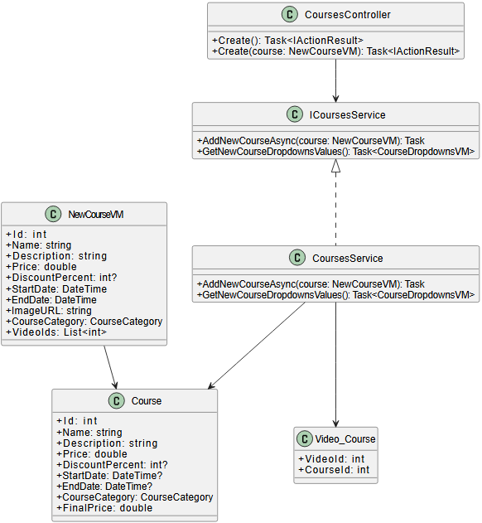

### b. Class Specifications

#### CoursesController

| **No** | **Method** | **Description** |
| --- | --- | --- |
| 01 | Create() | Prepares dropdown data and renders the form for creating a new course |
| 02 | Create(NewCourseVM course) | Validates input; if valid, passes to service to save course; redirects to course index |

#### CoursesService

| **No** | **Method** | **Description** |
| --- | --- | --- |
| 01 | GetNewCourseDropdownsValues() | Returns available videos from the DB to populate dropdown in the course creation form |
| 02 | AddNewCourseAsync(NewCourseVM) | Maps ViewModel to Course entity, associates selected videos, and saves all to DB |

#### AppDbContext

| **No** | **Method** | **Description** |
| --- | --- | --- |
| 01 | Courses | Inserts a new course record in the database |
| 02 | Videos_Courses | Inserts mapping records between the course and selected videos |

### c. Sequence Diagram

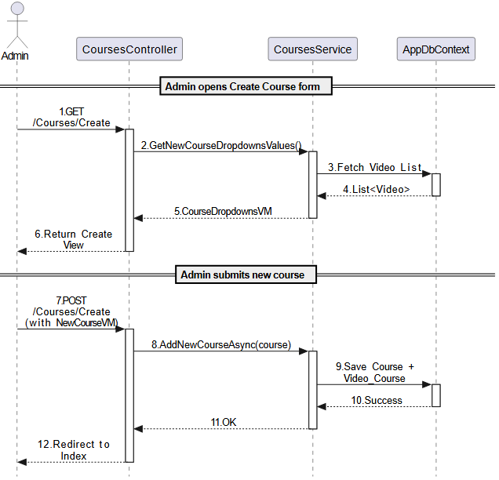

### d. Database Queries

INSERT INTO [Courses]

([Name], [Description], [Price], [DiscountPercent], [StartDate], [EndDate], [ImageURL], [CourseCategory])

VALUES

(@Name, @Description, @Price, @DiscountPercent, @StartDate, @EndDate, @ImageURL, @CourseCategory);

SELECT SCOPE_IDENTITY(); -- capture newly inserted Course.Id

INSERT INTO [Videos_Courses] ([VideoId], [CourseId])

VALUES

(@VideoId1, @CourseId),

(@VideoId2, @CourseId),

...;

## 

## 40. Edit a Course

**Use Case:** UC-32b: Edit a Course

### a. Class Diagram

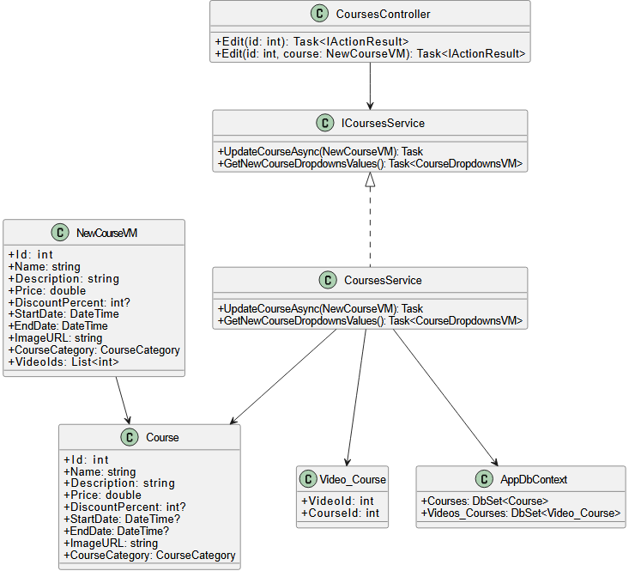

### b. Class Specifications

#### CoursesController

| **No** | **Method** | **Description** |
| --- | --- | --- |
| 01 | Edit(int id) | Loads existing course info + video IDs and returns prefilled form |
| 02 | Edit(int id, NewCourseVM course) | Validates and submits the updated course to the service layer |

#### ICoursesService / CoursesService

| **No** | **Method** | **Description** |
| --- | --- | --- |
| 01 | UpdateCourseAsync(NewCourseVM) | Updates course fields and related video associations in database |
| 02 | GetNewCourseDropdownsValues() | Retrieves available videos for the dropdown list |

### c. Sequence Diagram

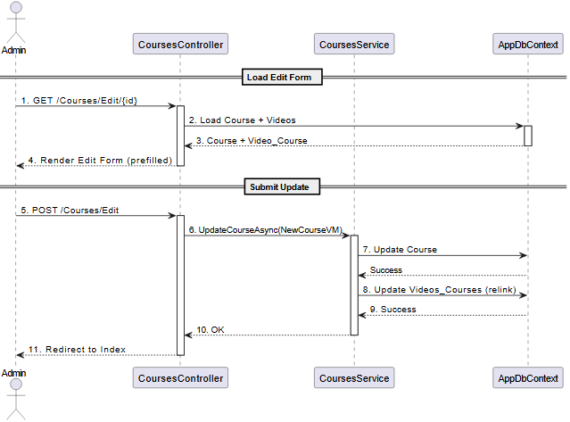

### d. Database Queries

SELECT * FROM Courses WHERE Id = @CourseId;

SELECT * FROM Videos_Courses WHERE CourseId = @CourseId;

UPDATE Courses

SET Name = @Name,

Description = @Description,

Price = @Price,

DiscountPercent = @DiscountPercent,

StartDate = @StartDate,

EndDate = @EndDate,

ImageURL = @ImageURL,

CourseCategory = @CourseCategory

WHERE Id = @CourseId;

DELETE FROM Videos_Courses WHERE CourseId = @CourseId;

INSERT INTO Videos_Courses (VideoId, CourseId)

VALUES

(@VideoId1, @CourseId),

(@VideoId2, @CourseId),

...;

## 41. Delete a Course

**Use Case:** UC-32c: Delete a Course

### a. Class Diagram

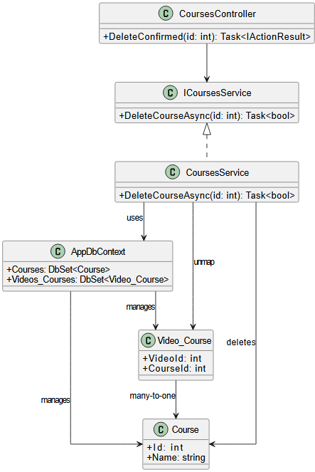

### b. Class Specifications

#### CoursesController

| **No** | **Method** | **Description** |
| --- | --- | --- |
| 01 | DeleteConfirmed(int id) | Calls service to delete course, then redirects to Index |

#### CourseService

| **No** | **Method** | **Description** |
| --- | --- | --- |
| 01 | DeleteCourseAsync(int id) | Finds course by ID, removes it, commits to DB |

#### AppDbContext

| **No** | **Method** | **Description** |
| --- | --- | --- |
| 01 | Courses | Table for storing courses |
| 02 | Videos_Courses | Table linking videos to courses (auto-deleted if FK cascade applies) |

### c. Sequence Diagram

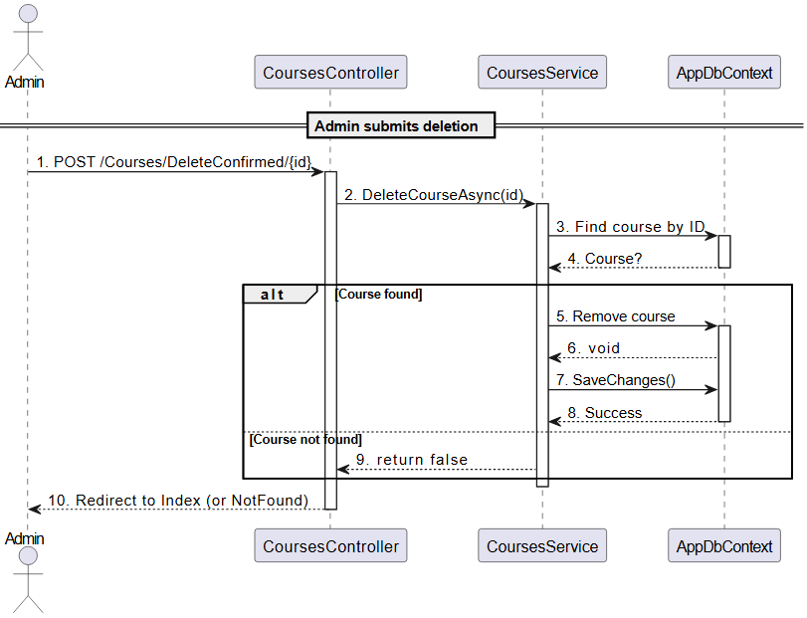

### d. Database Queries

-- 1. Find course by ID

SELECT * FROM Courses WHERE Id = @CourseId;

-- 2. Delete course

DELETE FROM Courses WHERE Id = @CourseId;

-- 3. (Optional) Delete related Video_Course mappings

-- If cascade delete is not configured

DELETE FROM Videos_Courses WHERE CourseId = @CourseId;